Registered Report: A Tale of Two Walks. Episodic Memory and Semantic Representations Both Guide Memory Retrieval
Achiel Fenneman & Claus Lamm
Department of Cognition, Emotion, and Methods in Psychology, University of Vienna

Author Note
Achiel Fenneman https://orcid.org/0000-0001-7214-5338
Claus Lamm https://orcid.org/0000-0002-5422-0653

We have no known conflict of interest to disclose.
All materials, raw data and analysis scripts are freely available online via https://osf.io/y72jh
Correspondence concerning this article should be addressed to Achiel Fenneman, Email: achiel.fenneman@univie.ac.at

Word count (excl. title, references, author affiliations, acknowledgments, figure legends): 5002

Abstract
Memory retrieval is guided by two complementary learning systems: an episodic memory system storing individual experiences, and a semantic knowledge system representing ‘things that belong together’. While much is known about these structures in isolation, their interplay has been comparatively less studied. In this work we propose a spotlight-cascade model, which characterizes the interplay between these systems through two walks: a cascading walk in episodic space and an autocorrelated walk in semantic space. The spotlight-cascade model yields three sets of hypotheses, which will be validated through an online experiment in which participants travel to a fictive island and interact with 16 fantasy animals, dubbed Fennimals. Some Fennimals are encountered in the same region of the island (creating episodic groups), whilst others share semantically similar heads and names (creating semantic groups). Participants are then asked to recall the names of these Fennimals. The sequence and time between recalled names will allow us to validate the hypothesized interaction between the episodic and semantic retrieval processes.

Introduction
How do we retrieve information from memory? The answer to this seemingly simple question is non-trivial. After all, the retrieval of knowledge from memory requires both the retrieval of singular events (e.g. ‘things that we have experienced’) as well as previously learned (statistical) regularities in our environment (‘things that belong together’). In other words, effective memory retrieval draws on the interplay between two complementary learning systems (Kumaran & McClelland, 2012; McClelland et al., 1995; O’Reilly et al., 1998): an episodic system which stores individual experiences, and a semantic system which stores information which is generalized across multiple experiences. While historically considered to be separate systems with minimal crosstalk (Tulving, 1972), recent findings increasingly demonstrate that these systems may be more intertwined than previously considered (De Brigard et al., 2022; Renoult et al., 2019). Episodic memories are more likely to be successfully stored and retrieved if they are embedded within existing semantic knowledge structures (Collins & Loftus, 1975; Tulving, 1962; Tulving & Thomson, 1973). Conversely, the formation of abstract representations has increasingly been linked to the replay of episodic memories during sleep (Klinzing et al., 2019). But how do these systems interact with each other during retrieval? That is, how does semantic knowledge guide the retrieval of individual experiences, and how do episodic memories facilitate the search of semantic knowledge?
In this work we propose that the flexible retrieval of information from memory is facilitated by two concurrent-but-interdependent retrieval walks: one in episodic space, and one in semantic space. Both walks occupy different computational and cognitive niches, have their own respective strengths and weaknesses, and rely on different, but interacting, retrieval mechanisms. On the one hand, the episodic memory system is neurologically centered on the hippocampus and stores past experiences in their contextual richness, including the where, what and when of the events (Figure 1A; Eichenbaum, 2017b, 2017a; Ergorul & Eichenbaum, 2004). The episodic system draws on this richness to sequentially retrieve experiences through a process of cascading retrieval (Figure 1B; Fenneman et al., 2025). In this process episodes are sequentially retrieved, whereby the elements of the memory (henceforth ‘features’) provide the input for a subsequent retrieval step. This episodic retrieval process follows a cascading walk across the episodic network (Figure 1C; Fenneman & Lamm, 2026b).
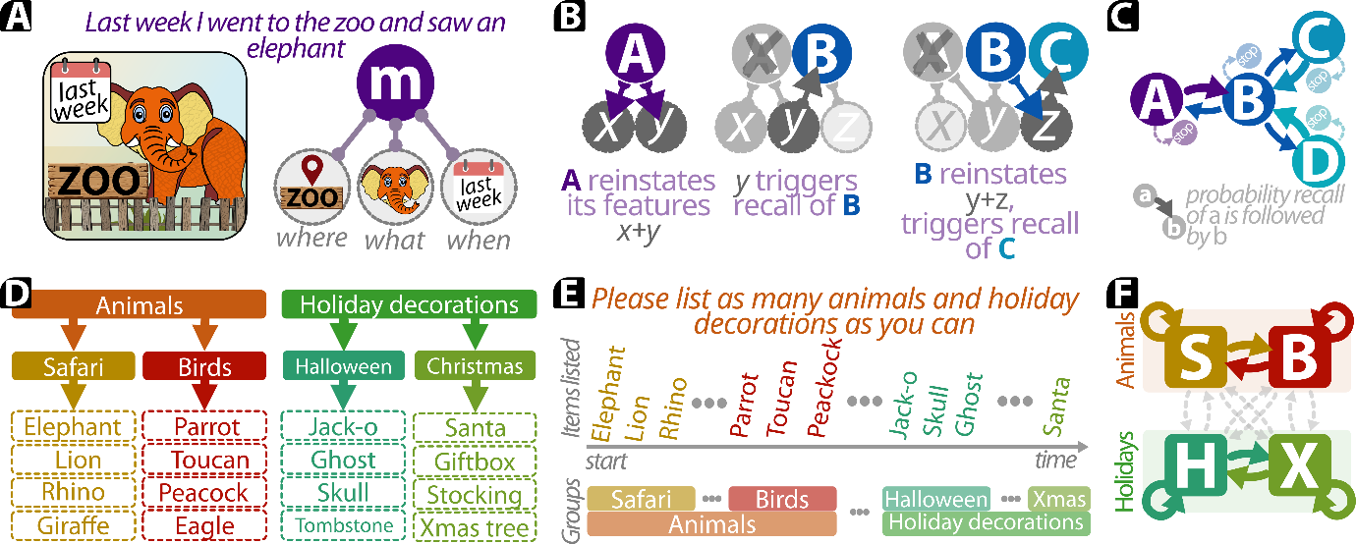
Figure 1: examples of the two complementary learning systems. A: episodic memories are stored as singular events, combining the constituent elements of the experience in a single ‘node’; in this example, the episode “last week I went wo the zoo and saw and elephant” is stored as the conjunction of ‘zoo’ (where), ‘an elephant’ (what) and ‘last week’ (when). B: episodic memories can be retrieved through a cascading retrieval process, whereby the recall of experience A reinstates its constituent element, which then triggers the retrieval of experience B. This experience then reinstates its own elements, resulting in the retrieval of memory C – even when A and C do not share any features. C: this cascading retrieval process can be represented by the first walk: a cascading walk on an associative graph, wherein each episode is represented as a node, and memories with overlapping features are linked with an edge. D: semantic knowledge is represented as a hierarchical set of groups, representing ‘things that belong together’. E: the retrieval of words is frequently clustered along semantic groups. F: such semantic grouping can be represented as an autocorrelated walk on the semantic network. This network represents low-level semantic groups as nodes, and paths between groups represent larger over-arching semantic clusters.
The representational richness of episodes comes at the cost of a narrow scope, as each memory pertains to a specific and singular event. In contrast, the semantic knowledge system stores generalized knowledge about which things belong together by representing (statistical) commonalities across related groups of features (Figure 1D; Ashby & Townsend, 1986; Baram et al., 2021; Ghosh & Gilboa, 2014; Gilboa & Marlatte, 2017; Kumaran et al., 2009; McClelland et al., 1995; Murphy & Ross, 1994; Nosofsky, 1986; Zeithamova et al., 2012; Zeithamova & Bowman, 2020). These semantic representations are hierarchically structured, gradually learned and are neurologically centered on the neocortex (McClelland et al., 1995; O’Reilly et al., 1998). In contrast to episodic memory, semantic knowledge is wide-but-austere, representing groups of co-occurring elements without their original context of observation. The semantic system retrieves information through the co-activation of related elements. The activation of one element enhances the probability of subsequently retrieving an element from the same group – resulting in the semantic clustering of elements during recall (Figure 1E; Fenneman & Lamm, 2026b). Several related (but distinct) mechanisms have been proposed to model this clustering, including the retrieval of semantic knowledge through a random walk in semantic space (Abbott, J. T. et al., 2012; Abbott et al., 2015), as an evolutionary exaptation of strategies pertaining to the optimal foraging in patchy environments (Hills et al., 2008, 2012, 2015), or through the activation of semantic contexts-nodes during the recall process (Howard & Kahana, 2002; Kahana, 2020; Lohnas et al., 2015; Polyn et al., 2009; Wickens, 1970). These approaches broadly represent the retrieval of semantic knowledge as an autocorrelated walk across the semantic network (Figure 1F).
In summary, both systems retrieve information through two separate walk processes: a cascading walk in episodic space, and an autocorrelated walk in semantic space. But how do these walks interact with each other to facilitate the flexible retrieval of past experiences? Here we propose that both types of memories and their postulated walks can be bridged by a single unifying framework: the spotlight-cascade model (Figure 2), which combines the contextual richness (but narrow scope) of the episodic cascading walk with the wider scope (but austere detail) of the semantic walk process.
As a starting point we build on the cascading episodic walk model (Fenneman et al., 2025), which consists of two layers: episodic memories and features (Figure 2A). The episodic layer represents different events as discrete memory nodes, each of which is connected to a set of (modality-agnostic) features reflecting the memory’s content. Memories are retrieved through sequential steps, each of which consists of a retrieval phase and a reinstatement phase. The retrieval phase starts with a set of activated features, which in turn activate any connected memories. If any memories reach a minimum threshold of activation, then one memory meeting this threshold is selected for recall. The retrieval process continues to the reinstatement phase after a memory is recalled, during which the retrieved memory reinstates all its constituent features. This pattern-completion forms a key component of the cascading recall process and provides the input for the next step of the retrieval process. To prevent repetitive loops, the retrieved episode is blocked from further retrieval during the remainder of the retrieval process. The search process continues until no memory reaches a threshold activation throughout the retrieval phase.
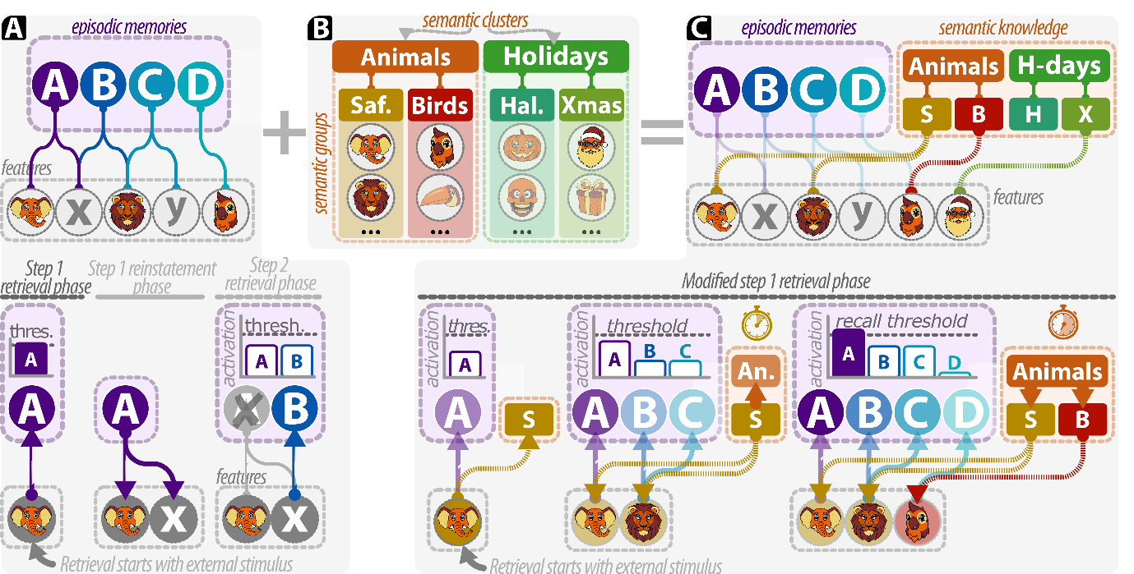
Figure 2: the spotlight-cascade model combines the cascading walk in episodic space with an autocorrelated semantic walk. A: the cascading recall model consists of two layers, such that each memory represents the conjunction of features observed in a single event. Retrieval of memories occurs in steps comprised of two phases. The retrieval phase starts with a set of activate features, which triggers the recall of at most a single memory. The retrieved memory then reinstates all of its constituent features, providing the input for the subsequent retrieval step. The retrieved memory is then block from further retrieval and the next step commences. B: semantic representations consist of multiple hierarchies. The lower layer (‘semantic groups’) represent features that ‘belong together’ (depicted here as four groups: safari animals, birds, Halloween and Christmas). A second hierarchical layer represents semantic clusters: which groups belong together (here: animals and Holidays). C: the spotlight-cascade model integrates the two systems into a single framework. The model consists of three layers: features, episodes and semantic groups. Note that the episodic and semantic system do not directly interact with each other but are instead connected to the same group of underlying features. In comparison to the cascade recall model, the combined spotlight-cascade model has an expanded retrieval phase. If the active features do not result in the retrieval of a memory, then these features recruit their semantic groups. These groups then increase activation for all their constituent features. If this still does not yield the retrieval of a memory, then the semantic groups recruit their semantic clusters, increasing activation of all features in the cluster.
In this work we extend the cascade model with a separate layer of semantic representations, which are organized into hierarchical levels (Figure 2B). For simplicity we limit our discussion to two levels of hierarchy: low-level semantic groups and higher-level clusters. Each semantic group is connected to a set of features, reflecting ‘things that belong together’ (i.e., the group ‘Safari animals’ represents the combination of ‘elephant’, ‘lion’, etc.). These groups are in turn connected to the higher-level semantic clusters. These clusters represent which semantic groups go together (i.e., the cluster ‘Animals’ contains both ‘Safari animals’ and ‘birds’).
These semantic representations guide the retrieval phase of the recall process. As in the cascading retrieval model, features spread their activation to any memories which contain these features. If no memory reaches a threshold level of activation, then the activate features recruit their associated semantic groups. These semantic groups then form a ‘spotlight’ by increasing activation of all the features which belong to this group (Figure 2E). This expanded set of active features increases the activation of any memories that contain these features. If this still does not result in the retrieval of a memory, then the active semantic groups further widen the memory search by recruiting all their associated semantic clusters (Figure 2F). These clusters then spotlight all their constituent groups, which in turn spotlights an even wider set of features.
The spotlight-cascade model yields three sets of predictions for the interaction between the episodic and semantic systems during memory retrieval, a summary of which is provided in Table S1 in the supplementary materials. First, the spotlight-cascade model replicates the cascading process (Fenneman et al., 2025; Fenneman & Lamm, 2026b), wherein the retrieval of an episodic memory increases the probability to retrieve another episodic memory with overlapping features (H_{1A}, Figure 3A). Through the semantic spotlight effect, the model replicates autocorrelated semantic models (Ashby & Townsend, 1986; Baram et al., 2021; Ghosh & Gilboa, 2014; Gilboa & Marlatte, 2017; Kumaran et al., 2009; McClelland et al., 1995; Murphy & Ross, 1994; Nosofsky, 1986; Zeithamova et al., 2012; Zeithamova & Bowman, 2020), whereby the retrieval of a memory increases the probability to sequentially retrieve memories with semantically similar features (H_{1B}, Figure 3B).
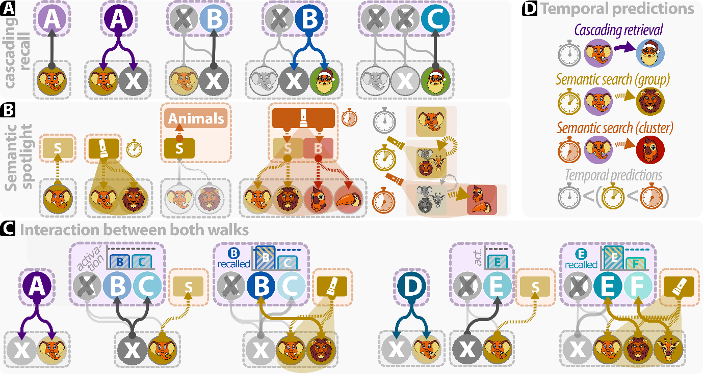
Figure 3: predictions for the spotlight-cascade model. A: the spotlight-cascade model replicates the predictions of the cascading recall process. The activation and subsequent reinstatement of memory A triggers the retrieval of memory B, which in turn triggers the retrieval of memory C. This order in which memories are retrieved forms a walk in episodic space. B: the spotlight-cascade model predicts a semantic spotlight effect. At first, an observed external stimulus triggers the activation of a semantic group (‘elephant’ actives ‘Safari animals’). If no memory has been recalled, then this semantic group then forms a spotlight: widening the search to other features in the same group (‘lion’). If this also does not yield the retrieval of a memory, then the semantic groups recruit their semantic cluster, widening the search to all features in the cluster (recruiting ‘birds’, consisting of ‘parrot’ and ‘toucan’). This process yields a walk in semantic space. C: the spotlight-cascade model predicts an interaction between both walks. If multiple memories contain the same features (‘X’), then the model predicts that the memory which non-overlapping features have the highest semantic similarity is most likely to be subsequently retrieved. Conversely, if multiple memories contain (non-overlapping) features from the same semantic group, then the model predicts that the memory with the largest episodic overlap is likely to be subsequently retrieved. D: in addition to the order in which memories are retrieved, the spotlight-cascade model also makes predictions on the time between subsequently retrieved experiences. As the cascading retrieval process does not require a semantic spotlight effect, experiences are fastest to be sequentially retrieved if they share overlapping features. If memories do not share overlapping features, they are faster to be sequentially retrieved when they contain features belonging to the same semantic group, as compared to when their features belong to different groups in the same semantic cluster.
In the spotlight-cascade model the retrieval of knowledge does not occur through either the cascading or semantic walk in isolation, but through the interplay between both walks (Figure 3C). The features of a reinstated memory may be shared by multiple other memories – resulting in a tie between competing memories. In this scenario, the spotlight effect forms a tie-breaker by preferentially retrieving the memory which has the highest semantic similarity in its non-overlapping features (H_{2A}). Conversely, when multiple episodes share semantically similar features, then the memory that has the highest episodic (that is, non-semantic) overlap with the previous memory has the highest probability of being retrieved (H_{2B},).
Finally, the spotlight-cascade model predicts a pattern in the time between subsequently retrieved memories (Figure 3D). The cascading retrieval process draws on the reinstated features of a previously retrieved memory. Conversely, the semantic spotlight effect occurs only after the cascading process does not yield the retrieval of a new memory. We therefore predict that the sequential retrieval of memories is faster when both share overlapping features as compared to two memories which are sequentially recalled based on the semantic similarity of their (non-overlapping) features (H_{3A}). Moreover, the semantic spotlight effect takes time to become more diffuse: the recruitment of semantic clusters follows only after the activation of all features in a semantic group does not yield the retrieval of a memory. We therefore predict that the semantic retrieval process is faster when both memories belong to the same semantic group, as compared to when they belong to different groups in the same cluster (H_{3B}).
The spotlight-cascade model sheds a new light on the interaction between episodic memories and semantic knowledge: the flexible retrieval of information from memory is not a function of either system in isolation, but follows from a dynamic interplay between both. The episodic memory system draws on past experiences by reinstating their narrow-but-rich features, whilst the semantic knowledge system informs and widens the memory search by spotlighting groups of features based on their (statistical) co-occurrence (i.e., which features belong together). In the spotlight-cascade model this interplay is conceptualized as multiple walks across multiple spaces (Figure 4); the retrieval of information occurs interdependently in feature-space (itself composed of spatial, object and temporal subspaces), episodic memory space and semantic space. In doing so the spotlight-cascade model extends recent applications of network science to the study of cognition (Baronchelli et al., 2013; Hills, 2024; Hills & Kenett, 2022; Reijneveld et al., 2007; Siew et al., 2019), which has shed new light on the cognitive mechanisms supporting spatial navigation (Peer et al., 2020; Tolman, 1948), the retrieval of semantic knowledge (Abbott, J. T. et al., 2012; Abbott et al., 2015), the formation of language (Kumar, 2021), creative cognition (Beaty et al., 2019), the representation of social networks (Hills & Pachur, 2012; Schafer & Schiller, 2018; Smith et al., 2020), and the retrieval of sequences of episodic events (Buzsáki & Tingley, 2018; Fenneman et al., 2025; Fenneman & Lamm, 2026b; Peer et al., 2021; Raju et al., 2024; Whittington et al., 2020). This body of work has traditionally explored the retrieval of information in a single space (e.g., episodic, semantic, spatial or social space). The spotlight-cascade model expands on this work by exploring the interplay between multiple spaces. Such dynamic interplay between cognitive spaces has thus far been rarely explored but promises a fruitful avenue for research across a wide range of cognitive phenomena.
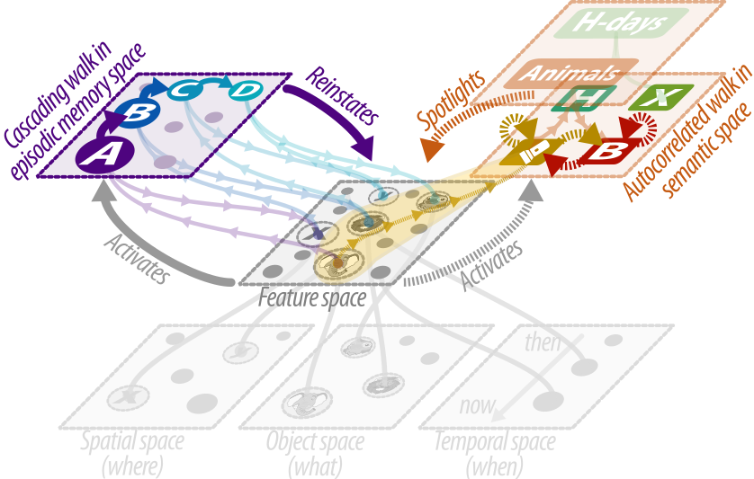
Figure 4: the spotlight-cascade model represents the retrieval of knowledge as a dynamic across multiple abstract spaces. Features are represented in a high-dimensional feature-space, composed of spatial (‘where’), object (‘what’) and temporal (‘when’) subspaces. These features act, and are acted upon, by a layer of episodic memories. When considered in episodic memory space, this interaction results in a cascading walk process. The features independently act, and are acted upon, abstract groups in semantic space. When considered in semantic space, this interaction results in an autocorrelated walk process. Although these processes occur in three distinct spaces, they are all interdependent in the model: as they both act on the same feature-space, the cascading walk (indirectly) guides the semantic walk – and vice versa.

Methods
We will evaluate our hypotheses through an online experiment based on the Fennimals paradigm (Fenneman et al., 2025), which was previously designed and validated to study the retrieval of episodic memories. We will extend this paradigm to include a semantic structure in the to-be-recalled stimuli. This section provides an overview of key elements in this new methodology, whilst an exhaustive documentation of all materials and the experiment procedure is provided in the Supplementary Information.

Ethics information
Ethical approval for this experiment has been obtained from the Ethics Committee of the University of Vienna.

Design

Materials
During the experiment participants will travel to a fictive island dubbed Fenneland. This island will consist of 4 visually and thematically distinct regions (Figure 5A). On this island, participants interact with 16 different cartoon creatures, dubbed Fennimals, by taking photos of these creatures (Figure 5B). The appearance of the Fennimals differ along two axes. First, the Fennimal’s native region on the island determines its color scheme and body type (Figure 5C). Therefore, any Fennimals located (“residing”) in the same region will share a set of overlapping features. By placing multiple Fennimals in the same region of the island, we can create different unique Fennimals with partially overlapping elements (the Fennimal’s location, body shape and color-scheme), thus creating a set of (partially overlapping) episodic events. In this experiment we will expand on this existing paradigm by imposing a semantic structure of the heads of the Fennimals. Based on a series of stimulus pilots, we created groups of visually distinct heads along two semantic clusters (a ‘animals’ and a ‘holiday’ theme), each of which contains two semantic groups (‘safari animals’ and ‘birds’ versus ‘Halloween’ and ‘Christmas’, respectively; Figure 5D). Each of these groups will contain four different types of heads, for a total of 16 different heads. We will validate the predictions of the spotlight-cascade by distributing the 16 Fennimals on the island. Each region will contain two pairs of two Fennimals belonging to semantic groups in different semantic clusters (Figure 5E). For example, one region will contain two ‘Safari’ heads and two ‘Halloween’ heads.
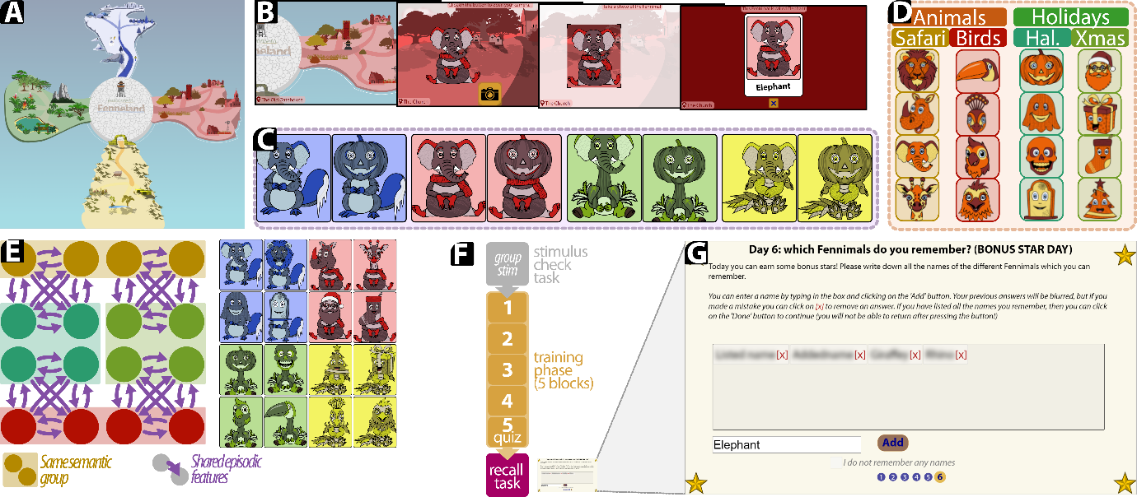
Figure 5: the modified Fennimals paradigm. A: Participants will travel to a fictive island dubbed “Fenneland”. This island will consist of four visually and thematically distinct regions (randomly selected from eight possible regions). B: on this island, they will interact with fantasy creatures, dubbed Fennimals, by taking photos of them. C: Fennimals which will be encountered in the same region will share overlapping features (color scheme, location and body) but have distinct heads. D: in this work we expand on the paradigm by introducing a semantic structure to the heads of the Fennimals. During the experiment, participants will interact with 16 Fennimals. The heads (and associated names) of these Fennimals will be clustered into eight ‘Animals’ (in turn consisting of four Safari animals and four birds) and eight Holiday-themed heads (consisting of four Halloween-themed heads and four Christmas-themed heads). E: The Fennimals will be placed on the island in pairs, such that each region contains two pairs of heads. These pairs will be selected to include one pair from one of the groups belonging to the “Animals” cluster (i.e., two Safari animals or two birds), whilst the other pair will be selected from the ‘Holiday’ cluster (i.e., two Halloween-themed heads or two Christmas-themed heads). The right side of the panel provides a set of example Fennimals. F: the experiment procedure. Each experiment will start with a stimulus check task to ensure that participants agree with our assumed semantic structure. Participants will then complete 5 blocks in the training phase, during which they interact with all 16 Fennimals. G: the last part of the experiment will consist of a recall task in which participants will be tasked with entering the names of all Fennimals they remember.

Procedure
The experiment will consist of three phases, conducted in a fixed sequence (Figure 4F). Each experiment starts with a stimulus check task, in which we ask participants to sort all 16 heads into four groups, and then organize these groups by similarity. This task will be included to validate whether the participant’s subjective semantic organization follows our predicted structure. Participants whose responses do not match our hypothesized semantic organization will be excluded from further analysis.
Participants will then continue to the main part of the experiment, which consists of 5 blocks. During each block the participants encounter all 16 Fennimals and will have to complete various tasks: either exploring the island (block 1), find all Fennimals on the map after being shown a visual depiction (block 2), organizing all Fennimals by the region of the island in which they were encountered (block 3), and find all Fennimals on the map based on their names (block 4). All these blocks are designed based on extensive pilot experiments, with the aim to maximize the probability that the participants will correctly commit all 16 Fennimals, and their constituent features, to memory. As a final incentive for participants to pay attention to all Fennimals, we will quiz them on their memory during the final block of this phase. This quiz will consist of 16 questions, one for each Fennimal. During each question, participants will be shown a (grayscale) picture of the Fennimal and are asked to indicate the region of the island in which this Fennimal lives, as well as to write down its name. Participants will earn a bonus of 0.10 USD per correctly answered quiz question.
During the final part of the experiment, we will ask participants to remember and write down the names of the different Fennimals they encountered during the experiment (Figure 4G). Here the software will attempt to match the entered names of the Fennimals to their actual names (allowing for small typos), keep track of the order in which these names are entered, and the time at which each name is entered. To incentive their performance, participants will earn a bonus of 0.10 USD per correctly entered name. After completing this phase, participants will be given a brief questionnaire containing items on their age and gender. This concludes the experiment.

Hypotheses
The two dependent variables for the experiment are the order in which the participants recall the names of these Fennimals at the end of the experiment, as well as the time between subsequently retrieved names. The first two hypotheses predict the order in which the names of these Fennimals are recalled. Based on the cascading recall process, we predict that participants will be more likely to sequentially retrieve the names of two Fennimals if they share episodic features, that is, if they were encountered in the same region of the island (H_{1A}). Based on the spotlight effect, participants are predicted to be more likely to sequentially retrieve the names of two Fennimals if their heads belong to the same semantic group or cluster (H_{1B}). The model next predicts that the retrieval process does not exclusively follow either the cascading or semantic walk – that is, it predicts that memories are not all recalled on an episode-by-episodic, nor on a semantic group-by-group basis. Instead, the model predicts an interplay between both walks. We therefore predict that, when two sequentially retrieved Fennimals were encountered in the same region of the island, participants are more likely to retrieve the names of the Fennimals which also belong to the same semantic group (H_{2A}). In addition, when two sequentially retrieved Fennimals have heads belonging to the same semantic group, participants will be most likely to sequentially recall those Fennimals that were also encountered in the same region (H_{2B}).
The third hypothesis predicts the time between subsequentially retrieved names. Specifically, episodic-based recall (i.e. the sequential retrieval of Fennimals in the same region) is predicted to have less time between sequential names as compared to semantic-based recall (i.e. the sequential retrieval of Fennimals in different regions, but with heads belonging to the same semantic group or cluster; H_{3A}). When retrieval does follow a semantic spotlight, then the sequential retrieval of two Fennimals is predicted to be faster if both have heads belonging to the same semantic group, as compared to different groups in the same semantic cluster (H_{3B}).

Exclusion Criteria
Participants will be excluded from further analyses if their responses on the stimulus check task do not follow the predicted pattern; that is, if they do not assign the Fennimals to their predicted category or if they do not place groups in the same semantic cluster closer to each other than to groups belonging to a different cluster. This exclusion criterium is included to ensure that the semantic structure of all remaining participants follows the hypothesized semantic structure.
In addition, the software will track two metrics to estimate the participant’s engagement with the experiment. At the start of the experiment, participants are requested to “please complete the experiment in a single continuous stretch”. Throughout the experiment, a timer will start whenever participants move focus to a different window and stops when the participant returns focus to the window. Participants will be excluded from further analysis if the total duration of this timer exceeds one minute throughout the experiment. While maintaining focus on the experiment software ensures that participants are not presently engaged in other tasks, it does not ensure that they are not distracted – either by content on a secondary monitor, or by other extraneous events. For this reason, the software will track the percentage of idle time, that is, the amount of time in which the participant does not move the cursor or press a key. This measurement will be started whenever the participant is inactive for at least 30 seconds and ends whenever the cursor is moved or key is pressed. Participants who have more than 5 minutes of idle time throughout the experiment may not have paid sufficient attention to the task and will be removed from further analyses.

Between-subjects Randomization
To prevent any confounding effects of the stimuli, the experiment software will randomize the Fennimals encountered by the participants on a between-subjects basis. At the start of each experiment, the software will select four regions out of a set of eight possible regions. The Fennimals will then be placed in these regions such that each region contains two pairs of two Fennimals. Both pairs will be selected from semantically different clusters, resulting in the creation of four groups: ‘Safari-Halloween’, ‘Safari-Christmas’, ‘bird-Halloween’ and ‘bird-Christmas’. These groups will then be randomly assigned to the four selected regions, and each group’s heads will be randomly assigned to different locations within this region.

Analysis plan

Preprocessing
Upon completing the experiment, the experiment software will store each participant’s data in JavaScript Object Notation (JSON). We collect the JSON objects for all participants and extract their data into two datasets. The first dataset will contain participant-level variables: the duration of the experiment, whether the participant correctly recreates the hypothesized semantic structure at the start of the experiment, the number of recalled names, total time spend away from full-screen mode, total idle time and demographic information. The second dataset will represent the names recalled by the participant, the order in which they are recalled, the time elapsed between sequentially recalled names, as well as the episodic and semantic groups of the named Fennimals. We will exclude the responses of any participants if they meet at least one of the exclusion criteria outlined above

Transforming recalled names into mnemonic sequential steps
We next transform each participant’s ordered list of recalled names into a series of steps along a mnemonic network. Each of these steps has a starting point (the previously retrieved name), an endpoint (the currently retrieved name) and an associated duration (the time between both entries). Thus, if a participant recalls k names, then this yields k-1 steps between names. For each step we will determine whether the step occurs within the same region (i.e., did both names belong to Fennimals which resided in the same region of Fenneland) and/or whether the names and heads of both Fennimals belong to the same semantic group and/or cluster. We next evaluate our hypotheses using a series of permutation tests.

Permutation test procedure
As participants are not expected to repeatedly enter the same name multiple times, our data will have an innate interdependency as pairs of sequentially retrieved names are not independent observations. Conversely, our hypothesized retrieval processes provide a clear set of null-hypotheses: if the null-hypothesis is true, participants sequentially retrieve names without consideration of the Fennimal’s semantic or episodic similarities. This implies that there is no predictable structure in the order through which the names of the Fennimals are retrieved. That is, the names of the Fennimals are retrieved in random order. Similarly, when considering the duration between sequentially retrieved names, the null-hypothesis holds that the time between sequentially recalled names is independent from any (semantic or episodic) similarity between the two Fennimals.
For these reasons we will evaluate our hypotheses through two sets of permutation tests, implementational details of which are provided in the Supplementary Information. For hypotheses H₁ and H₂, we will compare the order in which participants recall names to simulated groups of responses which followed the null-hypothesis. In each permutation, we simulate the same number of participants as in the observed data, but such that each simulated participant retrieves the names of the Fennimals through a random-walk process. We will then compute the frequency of overlapping episodic and semantic similarities for all names, resulting in a distribution of expected frequencies if the null-hypothesis is true. We will compare our observed frequencies against this simulated distribution to obtain a permuted p-value.
For hypothesis H₃ we will simulate different experiment results in which we randomly re-order the time duration of the recall steps. We then calculate the median response duration when the sequentially retrieved names of the Fennimals shared episodic or semantic features. This yields a distribution of median time durations in which the null-hypothesis is true, that is, under the assumption that the time duration of a step is independent from any (episodic or semantic) overlap between the Fennimals. We next compare the observed median time duration for steps in which the Fennimals shared episodic (H_{3A}) or semantically (H_{3B}) similar features, yielding one p-value for each hypothesis. Note that we will validate our hypotheses on the median, not mean, time duration. We will do so as the distribution of retrieval times between two names will be left-skewed; the time between two names will have a lower bound (it takes time to remember, type and enter names) whilst the maximum duration is unbounded. The mean duration time is therefore sensitive to outliers, and we will instead test the difference in median duration times.

Blinding procedure
Both data collection and analysis will be blinded. Specifically, the assignment of participants to the two treatments will be randomized by the participant’s web browser and will thus be conducted without intervention from the research time. In addition, we will blind the analysis procedure by submitting a finalized version of the analysis scripts prior to data-collection. Once the main data is collected, these analysis scripts will be run as they were written before data collection commenced, that is, blind to the experiment data.

Pilot data
We conducted two pilot experiments to test the feasibility of our methodology. The Fennimals paradigm was previously developed to explore episodic, but not semantic, retrieval. We therefore conducted a modified version of the experiment to validate the ability of our methodology to replicate previous findings on the semantic retrieval of memory. In this modified version we distributed the Fennimals on the island such that all Fennimals in the same region belonged to the same semantic group. We then conducted the experiment as outlined above and recorded the order in which participants recalled the names of these Fennimals. The results from this pilot experiment replicated previous work on the semantic structure of memory retrieval. The pattern in which participants retrieved these names was consistent with an autocorrelated walk in semantic space (Abbott, J. T. et al., 2012; Abbott et al., 2015): when retrieving the name of a Fennimal, the subsequent name most frequently belonged to either the same semantic group. If the name did not belong to the same group, then it was more likely than chance to belong to a different group in the same semantic cluster. Moreover, in line with models of optimal foraging in memory (Hills et al., 2008, 2012, 2015), the duration between sequentially retrieved names increased as participants recalled more names from the same group. Switching to a different semantic group incurred an additional penalty to this duration but was followed by a subsequent decrease in retrieval time after participants switched to a different group. All data collected during this pilot experiment can be freely retrieved from the OSF page associated to this registered report (Fenneman & Lamm, 2026a), and a detailed overview of the results are included in the Supplementary Information.
We next conducted a second pilot experiment to both evaluate the feasibility of our methodology to evaluate our hypotheses, as well as to inform our power analyses. This experiment was conducted in line with the procedure and stimuli outlined above. During this experiment, the software did not track the participant’s time away from the window or idle time. Instead, we excluded participants if their total experiment duration exceeded 3300 seconds (approximately twice the median duration of earlier pilot experiments). A total of 44 participants completed this second pilot experiment, 14 of which failed to recreate the predicted group structure in the stimulus check phase and/or had a total experiment duration exceeding the maximum duration and were excluded from further analysis. Of the remaining 30 participants, 12 identified as men and 17 as women (one participant preferred not to say), and they had a mean age of 30 years. The experiment had a median time to completion of 36.2 minutes and participants recalled a mean number of 14.5 out of 16 Fennimal names.
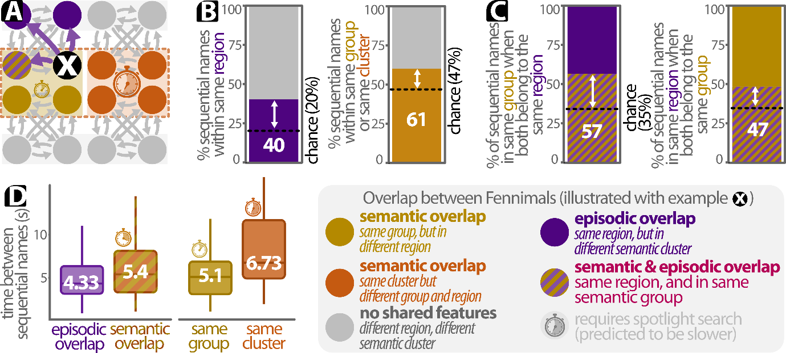
Figure 6: results for the pilot experiment. A: illustration for the overlap between different Fennimals, as illustrated from the perspective of Fennimal X. B: The order in which participants retrieved the names of the Fennimals is consistent with both the cascading and semantic walk processes. In line with the cascading recall process, participants were more likely than chance to sequentially retrieve the names belonging to Fennimals which resided in the same region (left panel). In line with the semantic spotlight effect, participants were more likely than chance to retrieve to sequentially retrieve the names of Fennimals whose heads belong to either the same semantic group or cluster (right panel). C: The order in which participants retrieved the names supported an interaction between both walks. When sequentially retrieving the names of two Fennimals with overlapping episodic features, participants were more likely than chance to recall the name of the Fennimal which also belonged to the same semantic group (left panel). In addition, when sequentially retrieving the names of two Fennimals in the same semantic group, then participants were more likely than chance to recall the name of the Fennimal which also resided in the same group (right panel). D: The time between sequentially retrieved names follows the predicted pattern. Participants were faster to sequentially retrieve the names of two Fennimals if they shared episodic features, as compared to when both Fennimals resided in different regions but had semantically similar heads (either in the same group or cluster; left panel). When participants sequentially retrieved the names of two Fennimals in different regions but with semantically overlapping heads, they were faster to do so when these heads belonged to the same semantic group as compared to different groups in the same semantic cluster. To enhance visual clarity this plot does not depict outliers.
The results of the pilot experiment confirm the feasibility of our methodology to address all hypotheses (Figure 6). Participants were more likely than chance to sequentially retrieve the names of two Fennimals if they resided in the same region (H_{1A}; Figure 6A) or when their heads belonged to the same semantic group (H_{1B}, Figure 6B). We observed an interaction between both recall processes (Figure 6C): when sequentially retrieving the names of two Fennimals in the same semantic group, participants were significantly more likely than chance to recall the name of the Fennimal which also shared episodic features (H_{2A}). Conversely, when sequentially recalling the names of two Fennimals with overlapping episodic features, participants were significantly more likely than chance to retrieve the name of the Fennimal in the same semantic group (H_{2B}). Finally, the time between sequentially retrieved names follows the predicted pattern (Figure 6D). Participants were faster when subsequently retrieving the names of two Fennimals if they shared episodic overlap as compared to when they occurred in different regions but had heads belonging to the same semantic group or cluster (H_{3A}, Figure 6E). If subsequent Fennimals did not share overlapping episodic features, then participants were faster to sequentially recall the names of Fennimals in the same semantic group as compared to Fennimals whose heads belonged to different groups in the same region. Note that no p-values are reported for this pilot experiment, as its results should be considered a general conformation of the feasibility of the design – not a critical evaluation of the hypotheses themselves.

Sampling plan
Based on the results obtained in the pilot data, we conducted a series of power simulations to determine a target sample size. Details on these simulations are included in the Supplementary Information, and the scripts used to obtain these results are available at the OSF page associated to this registered report (Fenneman & Lamm, 2026a). Based on these simulations, we will collect a sample consisting of 150 participants.

Data availability
Both the raw data (as collected during the experiment) and the cleaned data will be freely made available online via the OSF page (Fenneman & Lamm, 2026a). In addition, the data collected during the pilot experiment can already be found at this address. To ensure complete anonymity, we will delete the participant’s IP addresses prior to publication – but no other modifications will be made to the raw data prior to publication.

Code availability
The code used to conduct the experiment (HTML, JavaScript and CSS), as well as all scripts used to conduct the power simulations, clean the data and analyze the results will be freely available via the OSF page (Fenneman & Lamm, 2026a).

References
Abbott, J. T., Austerweil, J. L., & Griffiths, T. L. (2012). Human memory search as a random walk in a semantic network. NIPS, 3050–3058.
Abbott, J. T., Austerweil, J. L., & Griffiths, T. L. (2015). Random walks on semantic networks can resemble optimal foraging. Psychological Review, 122(3), 558–569. https://doi.org/10.1037/a0038693
Ashby, F. G., & Townsend, J. T. (1986). Varieties of perceptual independence. Psychological Review, 93(2), 154–179. https://doi.org/10.1037/0033-295X.93.2.154
Baram, A. B., Muller, T. H., Nili, H., Garvert, M. M., & Behrens, T. E. J. (2021). Entorhinal and ventromedial prefrontal cortices abstract and generalize the structure of reinforcement learning problems. Neuron, 109(4), 713-723.e7. https://doi.org/10.1016/j.neuron.2020.11.024
Baronchelli, A., Ferrer-i-Cancho, R., Pastor-Satorras, R., Chater, N., & Christiansen, M. H. (2013). Networks in Cognitive Science. Trends in Cognitive Sciences, 17(7), 348–360. https://doi.org/10.1016/j.tics.2013.04.010
Beaty, R. E., Seli, P., & Schacter, D. L. (2019). Network neuroscience of creative cognition: mapping cognitive mechanisms and individual differences in the creative brain. Current Opinion in Behavioral Sciences, 27, 22–30. https://doi.org/10.1016/j.cobeha.2018.08.013
Buzsáki, G., & Tingley, D. (2018). Space and Time: The Hippocampus as a Sequence Generator. Trends in Cognitive Sciences, 22(10), 853–869. https://doi.org/10.1016/j.tics.2018.07.006
Collins, A. M., & Loftus, E. F. (1975). A spreading-activation theory of semantic processing. Psychological Review, 82(6), 407–428. https://doi.org/10.1037/0033-295X.82.6.407
De Brigard, F., Umanath, S., & Irish, M. (2022). Rethinking the distinction between episodic and semantic memory: Insights from the past, present, and future. Memory & Cognition, 50(3), 459–463. https://doi.org/10.3758/s13421-022-01299-x
Eichenbaum, H. (2017a). On the Integration of Space, Time, and Memory. Neuron, 95(5), 1007–1018. https://doi.org/10.1016/j.neuron.2017.06.036
Eichenbaum, H. (2017b). Time (and space) in the hippocampus. Current Opinion in Behavioral Sciences, 17, 65–70. https://doi.org/10.1016/j.cobeha.2017.06.010
Ergorul, C., & Eichenbaum, H. (2004). The hippocampus and memory for [ldquo]what,[rdquo] [ldquo]where,[rdquo] and [ldquo]when.[rdquo]. Learn. Mem., 11(13), 397–405. https://doi.org/10.1101/lm.73304.mals
Fenneman, A., & Lamm, C. (2026a). OSF Page for A Tale of Two Walks. https://doi.org/https://doi.org/10.17605/OSF.IO/Y72JH
Fenneman, A., & Lamm, C. (2026b). Retrieving non-cued episodic memories by taking a cascading walk down memory lane(s) (In press). Journal of Experimental Psychology: General, 155(5). https://doi.org/10.1037/xge0001920
Fenneman, A., Malamut, S. T., & Sanfey, A. G. (2025). Retrieving past experiences to inform novel decisions through a process of cascading episodic sampling. Cognitive Psychology, 159, 101744. https://doi.org/10.1016/j.cogpsych.2025.101744
Ghosh, V. E., & Gilboa, A. (2014). What is a memory schema? A historical perspective on current neuroscience literature. Neuropsychologia, 53(1), 104–114. https://doi.org/10.1016/j.neuropsychologia.2013.11.010
Gilboa, A., & Marlatte, H. (2017). Neurobiology of Schemas and Schema-Mediated Memory. Trends in Cognitive Sciences, 21(8), 618–631. https://doi.org/10.1016/j.tics.2017.04.013
Hills, T. T. (2024). Behavioral Network Science. Cambridge University Press. https://doi.org/10.1017/9781108883894
Hills, T. T., Jones, M. N., & Todd, P. M. (2012). Optimal foraging in semantic memory. Psychological Review, 119(2), 431–440. https://doi.org/10.1037/a0027373
Hills, T. T., & Kenett, Y. N. (2022). Is the Mind a Network? Maps, Vehicles, and Skyhooks in Cognitive Network Science. Topics in Cognitive Science, 14(1), 189–208. https://doi.org/10.1111/tops.12570
Hills, T. T., & Pachur, T. (2012). Dynamic search and working memory in social recall. Journal of Experimental Psychology: Learning Memory and Cognition, 38(1), 218–228. https://doi.org/10.1037/a0025161
Hills, T. T., Todd, P. M., & Goldstone, R. L. (2008). Search in external and internal spaces: Evidence for generalized cognitive search processes. Psychological Science, 19(8), 802–808. https://doi.org/10.1111/j.1467-9280.2008.02160.x
Hills, T. T., Todd, P. M., & Jones, M. N. (2015). Foraging in Semantic Fields: How We Search Through Memory. Topics in Cognitive Science, 7(3), 513–534. https://doi.org/10.1111/tops.12151
Howard, M. W., & Kahana, M. J. (2002). A distributed representation of temporal context. Journal of Mathematical Psychology, 46(3), 269–299. https://doi.org/10.1006/jmps.2001.1388
Kahana, M. J. (2020). Computational Models of Memory Search. Annual Review of Psychology, 71(1), 107–138. https://doi.org/10.1146/annurev-psych-010418-103358
Klinzing, J. G., Niethard, N., & Born, J. (2019). Mechanisms of systems memory consolidation during sleep. Nature Neuroscience, 22(October). https://doi.org/10.1038/s41593-019-0467-3
Kumar, A. A. (2021). Semantic memory: A review of methods, models, and current challenges. Psychonomic Bulletin & Review, 28(1), 40–80. https://doi.org/10.3758/s13423-020-01792-x
Kumaran, D., & McClelland, J. L. (2012). Generalization through the recurrent interaction of episodic memories: A model of the hippocampal system. Psychological Review, 119(3), 573–616. https://doi.org/10.1037/a0028681
Kumaran, D., Summerfield, J. J., Hassabis, D., & Maguire, E. A. (2009). Tracking the Emergence of Conceptual Knowledge during Human Decision Making. Neuron, 63(6), 889–901. https://doi.org/10.1016/j.neuron.2009.07.030
Levenshtein, V. I. (1966). Binary codes capable of correcting deletions, insertions, and reversals. Soviet Physics Doklady, 10(8), 707–710.
Lohnas, L. J., Polyn, S. M., & Kahana, M. J. (2015). Expanding the scope of memory search: Modeling intralist and interlist effects in free recall. Psychological Review, 122(2), 337–363. https://doi.org/10.1037/a0039036
McClelland, J. L., McNaughton, B. L., & O’Reilly, R. C. (1995). Why there are complementary learning systems in the hippocampus and neocortex: Insights from the successes and failures of connectionist models of learning and memory. Psychological Review, 102(3), 419–457. https://doi.org/10.1037/0033-295X.102.3.419
Murphy, G. L., & Ross, B. H. (1994). Predictions From Uncertain Categorizations. Cognitive Psychology, 27(2), 148–193. https://doi.org/10.1006/cogp.1994.1015
Nosofsky, R. M. (1986). Attention, similarity, and the identification–categorization relationship. Journal of Experimental Psychology: General, 115(1), 39–57. https://doi.org/10.1037/0096-3445.115.1.39
O’Reilly, R. C., Norman, K. A., & McClelland, J. L. (1998). A hippocampal model of recognition memory. Advances in Neural Information Processing Systems, 73–79.
Peer, M., Brunec, I. K., Newcombe, N. S., & Epstein, R. A. (2020). Structuring Knowledge with Cognitive Maps and Cognitive Graphs. 37–54. https://doi.org/10.1016/j.tics.2020.10.004
Peer, M., Brunec, I. K., Newcombe, N. S., & Epstein, R. A. (2021). Structuring Knowledge with Cognitive Maps and Cognitive Graphs. Trends in Cognitive Sciences, 25(1), 37–54. https://doi.org/10.1016/j.tics.2020.10.004
Polyn, S. M., Norman, K. A., & Kahana, M. J. (2009). A Context Maintenance and Retrieval Model of Organizational Processes in Free Recall. Psychological Review, 116(1), 129–156. https://doi.org/10.1037/a0014420
Raju, R. V., Guntupalli, J. S., Zhou, G., Wendelken, C., Lázaro-Gredilla, M., & George, D. (2024). Space is a latent sequence: A theory of the hippocampus. Science Advances, 10(31). https://doi.org/10.1126/sciadv.adm8470
Reijneveld, J. C., Ponten, S. C., Berendse, H. W., & Stam, C. J. (2007). The application of graph theoretical analysis to complex networks in the brain. Clinical Neurophysiology, 118(11), 2317–2331. https://doi.org/10.1016/j.clinph.2007.08.010
Renoult, L., Irish, M., Moscovitch, M., & Rugg, M. D. (2019). From Knowing to Remembering: The Semantic–Episodic Distinction. Trends in Cognitive Sciences, 23(12), 1041–1057. https://doi.org/10.1016/j.tics.2019.09.008
Schafer, M., & Schiller, D. (2018). Navigating Social Space. Neuron, 100(2), 476–489. https://doi.org/10.1016/j.neuron.2018.10.006
Siew, C. S. Q., Wulff, D. U., Beckage, N. M., & Kenett, Y. N. (2019). Cognitive Network Science: A Review of Research on Cognition through the Lens of Network Representations, Processes, and Dynamics. Complexity, 2019(1). https://doi.org/10.1155/2019/2108423
Smith, E. B., Brands, R. A., Brashears, M. E., & Kleinbaum, A. M. (2020). Social Networks and Cognition. Annual Review of Sociology, 46(1), 159–174. https://doi.org/10.1146/annurev-soc-121919-054736
Tolman, E. C. (1948). Cognitive maps in rats and men. Psychological Review, 55(4), 189–208.
Tulving, E. (1962). Subjective organization in free recall of “unrelated” words. Psychological Review, 69(4), 344–354. https://doi.org/10.1037/h0043150
Tulving, E. (1972). Episodic and Semantic Memory. In E. Tulving & W. Donaldson (Eds.), Organization of memory (pp. 381–403). Academic Press.
Tulving, E., & Thomson, D. M. (1973). Encoding specificity and retrieval processes in episodic memory. Psychological Review, 80(5), 352–373. https://doi.org/10.1037/h0020071
Whittington, J. C. R., Muller, T. H., Mark, S., Chen, G., Barry, C., Burgess, N., & Behrens, T. E. J. (2020). The Tolman-Eichenbaum Machine: Unifying Space and Relational Memory through Generalization in the Hippocampal Formation. Cell, 183(5), 1249-1263.e23. https://doi.org/10.1016/j.cell.2020.10.024
Wickens, D. D. (1970). Encoding categories of words: An empirical approach to meaning. Psychological Review, 77(1), 1–15. https://doi.org/10.1037/h0028569
Zeithamova, D., & Bowman, C. R. (2020). Neurobiology of Learning and Memory Generalization and the hippocampus : More than one story ? 175(September). https://doi.org/10.1016/j.nlm.2020.107317
Zeithamova, D., Schlichting, M. L., & Preston, A. R. (2012). The hippocampus and inferential reasoning: Building memories to navigate future decisions. Frontiers in Human Neuroscience, 6(2012–03), 1–14. https://doi.org/10.3389/fnhum.2012.00070

Acknowledgements
This work was supported by the Austrian Science Fund (FWF; project number ESP4762325). The funders have/had no role in study design, data collection and analysis, decision to publish or preparation of the manuscript.

Author Contributions
AF: conceptualization, formal analysis, investigation, methodology, software, visualization, writing – original draft. CL: project administration, resources, supervision, writing – original draft.

Competing interests
The authors declare no competing interests.

Supplementary Information: Table S1
Question | Hypothesis | Outcome measure | Sampling plan | Analysis Plan | Interpretation given to different outcomes
Does the order in which names are retrieved from memory follow the episodic structure of the stimuli? | H_{1A}: Participants are more likely to sequentially recall the names of Fennimals if they share episodic features – that is, if they were both encountered in the same region. | The frequency of sequentially retrieved names where both belong to Fennimals in the same region. | Based on the results of a power simulation (details provided in the supplementary information), we will collect the responses of 150 valid participants. | The frequency in which two sequentially retrieved names belong to Fennimals which were observed in the same region is larger than expected based on chance. Evaluated with a permutation test. | A failure to replicate previous research on the retrieval of past experiences through a cascading recall process.
The semantic spotlight effect: does the order in which participants retrieve the names of the Fennimals follow the semantic structure imposed in the experiment? | H_{1B}: Participants are more likely to sequentially recall the names of Fennimals whose heads and names belong to the same semantic group or semantic cluster. | The frequency of sequentially retrieved names which both belong to Fennimals in the same semantic group or semantic cluster. |  | The frequency of sequentially retrieved names which belong to Fennimals in the same semantic group AND/OR semantic cluster is larger than expected based on chance. Evaluated with a permutation test. | A failure to induce a semantic spotlight search in the current experiment design.
When sequentially retrieving the names of two Fennimals which share episodic features, are participants more likely to retrieve the name of a Fennimal which ALSO belongs the same semantic group? | H_{2A}: when two sequentially recalled names belong to Fennimals with the same episodic features, then the frequency in which they also belong to the same semantic group is larger than expected based on chance. | The relative share of sequentially recalled names which both belong to the same group AND region, as a fraction of all sequentially recalled names where both were observed in the same region. |  | For all pairs of sequentially retrieved names in which both Fennimals were encountered in the same region, the relative frequency of names belonging to Fennimals in the same semantic group is larger than based on chance alone. Evaluated with a permutation test. | The relative strength of the semantic spotlight effect is substantially stronger than the relative added effect of the cascading recall process. Consequently, the retrieval process is dominated by the semantic spotlight effect.
When sequentially retrieving the names of two Fennimals which belong to the same semantic group, are participants more likely to retrieve the name of a Fennimal which ALSO shares episodic features? | H_{2B}: when two sequentially recalled names belong to Fennimals in the same semantic group, then the frequency in which they also share episodic features is larger than expected based on chance. | The relative share of sequentially recalled names where both belong to the same group AND region, as a fraction of all sequentially recalled names where both belong to the same semantic group. |  | For all pairs of sequentially retrieved names in which both Fennimals share the same semantic group, the relative frequency of names belonging to Fennimals which were encountered in the same region is larger than based on chance alone. Evaluated with a permutation test. | The relative strength of the cascading recall process is substantially stronger than the relative added effect of the semantic spotlight. Consequently, the retrieval process is dominated by the cascading retrieval process.
Is the sequential recall of names faster if both Fennimals share episodic features as compared to when they only share a semantic similarity (i.e., if recalled is based on the semantic spotlight effect)? | H_{3A}: the median retrieval time between two sequentially retrieved names is lower when both Fennimals share episodic features, as compared to when both Fennimals share semantic features (but do not share episodic features). | The time elapsed between two sequentially recalled names. |  | The difference between the median* retrieval time when both names belong to the same semantic group or cluster (but were observed in different regions), minus the median retrieval time when both names belong to Fennimals in the same regions is larger than based on chance alone. Evaluated with a permutation test. | The difference in retrieval times may be too short to reliably detect in an online experiment, and/or our experimental methodology is insufficiently sensitive to these differences in duration. Future follow-up studies are needed.
Does the semantic spotlight effect follow the predicted temporal pattern? (i.e., does it require less time to sequentially recall the names of Fennimals from the same semantic group as compared to the same semantic cluster?) | H_{3B}: The median recall duration between two sequentially recalled names is shorter when both Fennimals belong to the same semantic group, as compared to when both Fennimals belong to different groups in the same semantic cluster. | The time elapsed between two sequentially recalled names. |  | The difference in the median* retrieval times between names in the same cluster (but different groups), minus the median retrieval time between names in the same semantic group (but belonging to Fennimals in different regions) is larger than based on chance. Evaluated with a permutation test. | The difference in retrieval times may be too short to reliably detect in an online experiment, and/or our experimental methodology is insufficiently sensitive to these differences in duration. Future follow-up studies are needed.
* The distribution of retrieval times between two names is predicted to be left-skewed; while the minimum duration is bounded by a minimal time for participants to type and enter names, the maximum duration is unbounded. We therefore do not compare the means in duration times (which are sensitive to outliers) but instead test the difference in median duration times.

Supplementary Information: Expanded Methods

Materials

Regions and locations
During the experiment, participants travelled to a fictive island called Fenneland (Figure S1A). This island counted 8 different regions, which were created to be visual and thematically distinct from each other. Each region contained four different locations which could be visited by participants (Figure S1B). At the start of each experiment (that is, on a between-subjects basis) four of these regions were selected at random, and the remaining 4 were removed from the island to minimize the visual complexity of the experiment (Figure S1C).
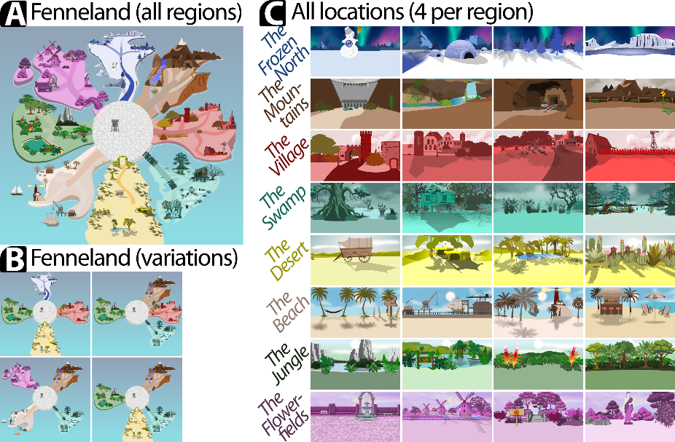
Figure S1: Fenneland and its locations. A: Fenneland consisted of 8 different regions, all displayed here. These regions were arranged in a circle around a center and were constructed to be both visually and thematically distinct from each other. B: at the start of each experiment, the software selected 4 regions, and only these regions were visited during the experiment. This selection was randomized on a between-subjects basis. In order to reduce the visual complexity of the experiment, the remaining four regions were removed from the map and could not be visited by the participant. C: Each region of Fenneland contained four visitable locations. Each location was selected to be visually distinct from all other locations within the same region.

Fennimals
During the experiment, each participant interacted with 16 different fantasy animals, dubbed Fennimals (Figure S2). These Fennimals differed along two axes: their region on the map and their head. The region of the island in which the Fennimal was encountered determined the shape of their bodies and their color-schemes (Figure S2A). Therefore, any Fennimals which are located in the same region share a set of overlapping episodic features. In addition, the design of the software allowed us to independently vary the shape of the Fennimals’ heads (Figure S2B). In the current experiment we expanded on the existing paradigm by creating the Fennimal’s heads along two semantic clusters (‘animals’ and a ‘holiday’ theme), each of which contained two semantic groups (‘safari animals’, ‘birds’ versus ‘Halloween’ and ‘Christmas’, respectively). Each of these groups consisted of four different head types. All of these stimuli were created based on a series of stimulus pilot experiments. Within a single experiment, each head uniquely identified a single Fennimal – and each Fennimal had a different head. This setup allowed us to create groups of Fennimals which had shared episodic features (that is, they were encountered in the same region of Fenneland, and shared a color-scheme and body type), but which did not share any semantically similar features (Figure S2C). Alternatively, we could also create groups of Fennimals which did not share any episodic features (that is, they were all encountered in different regions of Fenneland), but whose heads belonged to the same semantic group (Figure S2D).
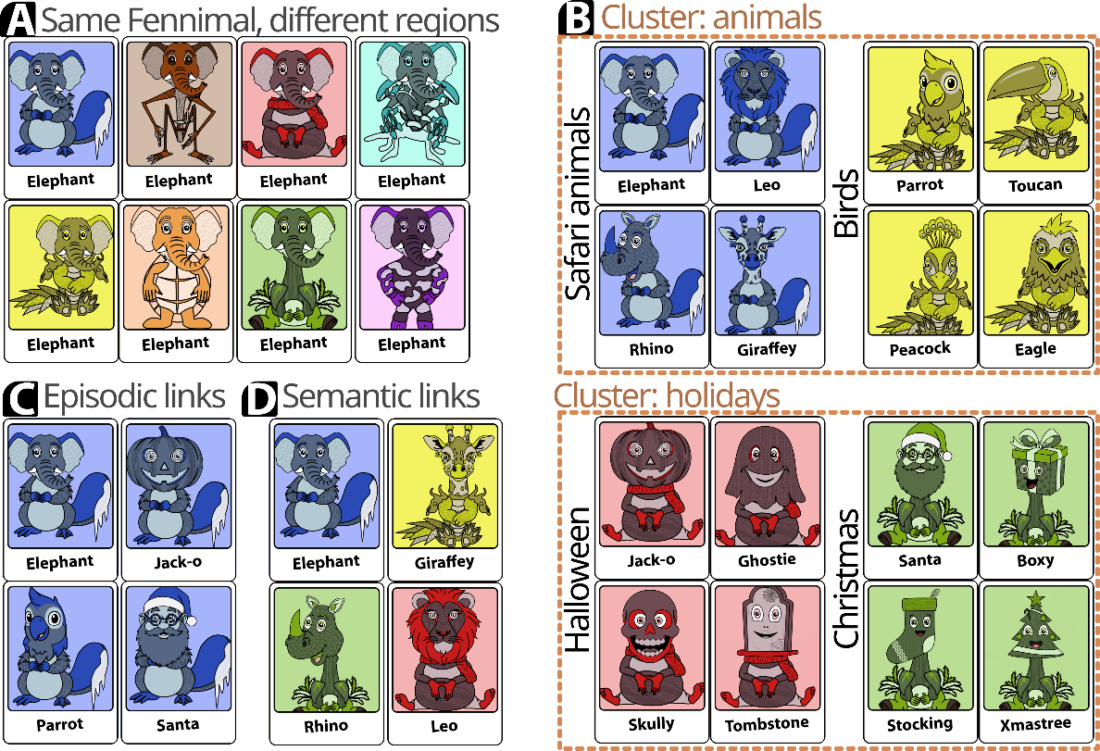
Figure S2: Fennimals. A: eight versions of a Fennimal with the same head (“Elephant”), with one version for each region of Fenneland. Note that each region had its own unique color-scheme and body shape. B: All Fennimals and their associated names. C: Fennimals in the same region shared the same colors-scheme and body type, thus creating overlapping episodic features between them. D: Fennimals with heads belonging to the same semantic clusters share a semantic connection – even if they do not share any overlapping episodic features.

Interaction with the Fennimals
During the training phase of the experiment (details follow below) participants could freely travelled across the island by moving a player icon with their mouse cursor (Figure S3A). When entering a region of the map, the software moved the map to center this region on the screen (Figure S3B). Participants could then travel across this region. If the player icon came sufficiently close to a visitable location which contained a Fennimal, then an icon containing a magnifying glass appeared over the location (Figure S3C). Holding down on this magnifying glass triggered a ’search’ of the region, after which participants could enter the location (Figure S3D). Upon entering, the background of the screen changed to reflect this location, and a Fennimal was presented on the screen (Figure S3E).
If the participant had already interacted with this Fennimal during the block, then a text message on top of the screen read “You already took a photo of [name]”. A button on the center bottom of the screen then allowed the participant to return to the map. If the participant had not yet encountered the Fennimal during this block, then they were instructed to make a photo of the Fennimal. A button containing an icon representing a camera appeared at the bottom of the screen (Figure S3F). Clicking on this button triggered a switch to ‘camera-mode’, which added a partially opaque element to the screen, mimicking a camera viewfinder (Figure S3G). This viewfinder followed the participant’s cursor. Participants could take a photo by clicking on their screen. When a photo was taken, the software determined whether or not the head of the Fennimal was sufficiently close to the center of the viewfinder to constitute a successful photo. If the photo was not successful, then the viewfinder disappeared and the participants were instructed to make another photo by the accompany text “Oops, that wasn’t it… please try again”. Upon making a correct photo the background of the location disappeared and the participant was shown a polaroid-frame containing the Fennimal (Figure S3H).
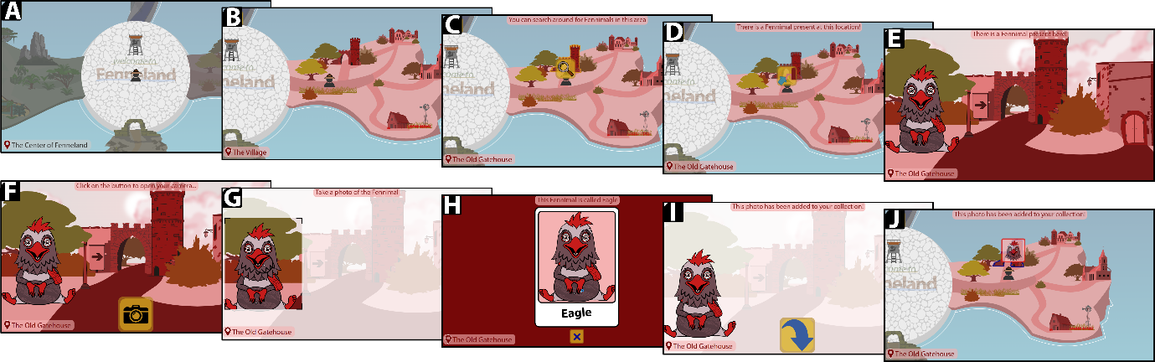
Figure S3: interaction with a single Fennimal during the training phase. A: at the start of each block in the training phase participants were placed on the center of the map. Here the black icon represents the player, which could be moved by pressing the cursor anywhere one the screen – which would cause the icon to move towards the cursor. B: when participants entered a region, the map shifted to center the region on the screen. This shift also triggered the region-specific background audio. C: a searchlight icon appeared over a visitable location if the play icon moved sufficiently close to this location. Holding down on this icon for 3 seconds triggered a ‘search’ of this location. D: if a Fennimal was present in this location, then searchlight icon changed to allow the participant to enter the location. Pressing this new region transitioned the player to the location. E: when entering a location, the present Fennimal was displayed somewhere on the screen. The x-position of this Fennimal was randomized for each interaction. F: after a 1 second delay, a photograph button appeared on the bottom of the screen. G: pressing the button triggered a ‘camera-mode’, indicated by a viewfinder following the cursor of the participant. The participant could then click anywhere on the screen to make a photo (which was accompanied by a shutter sound effect). H: If the participant clicked on a location sufficiently close to the head of the Fennimal, then a successful photo was taken. The background of the location now shifted to a solid color (the color depended on the color-scheme of the region), the Fennimal was moved to the center of the screen and a polaroid frame appeared. During trials in the first block of the training phase, this frame contained the name of the Fennimal. During subsequent blocks, the participant was tasked with typing the name of the Fennimal on the same location. I: after clicking on the ‘x’ below the photo, the location background reappeared and the participant could leave the location. J: after leaving the location, an icon representing this Fennimal now appeared on top of the location – and the location could no longer be visited during this block. These icons remained for the duration of each block, but were removed at the start of a subsequent block.
Depending on the trial, this frame either already contained the name of the Fennimal, or contained a text-input field in which the participant could enter the name of the Fennimal. In the latter case, text at the top of the screen displayed the line: “What is this Fennimal’s name? (Hit enter to confirm)”. Upon pressing enter the software checked the participant’s input. If the input has more than two points of difference from the correct name, that is, if the Levenshtein difference (Levenshtein, 1966) between the actual name and the input was more than two, then the name was color-coded in red and a text message at the top of the screen read “Nope, that’s not it… Please try again!”. If the input had a Levensthein distance of one or two, then the text was color-coded in orange and accompanied by a message reading “Almost there, but not quite right yet…”. The interaction was completed when the participant entered the correct name or when three incorrect names were entered. Participants could exit the photo-from by pressing a button on the bottom of the screen, which caused the frame to disappear and the Fennimal to return to its original position (Figure S3I). Participants could then freely leave the location to continue travelling across the island. As a memory guide, the map then displayed the icon of all interacted-with Fennimals on the map for the remainder of the block (Figure S3J).

Audio
In order to maximize participants’ engagement with the software, all interactions done by the participants were accompanied by a sound effect. These include audible sounds when pushing buttons, dragging and placing cards, making a photo or searching locations. In addition, to help differentiate the different regions, each region had its own (thematically appropriate) sound-track, which played in the background whenever the participant was present in the region.

Procedure
At the start of each experiment participants gave informed consent and were requested to set the experiment to full-screen in order to minimize potential distractors. Participants were informed at the start of the experiment that they could earn a number of bonus stars throughout the experiment, and that each star was worth $0.10 USD. The experiment consisted of three sequential phases: a stimulus check, training and recall phase. The exact setup of these tasks was based on a series of pilot experiments, and was created with the intention of maximizing participant’s ability to memorize the different stimuli – whilst minimizing the total experiment duration. This minimized duration decreased the probability that participants would be distracted or lose attention during the experiment.

Stimulus check phase
The experiment started with a stimulus check task (Figure S4), which was included to verify that a participant’s subjective semantic structure was consistent with our hypothesized grouping. This task consisted of two parts. During the first part participants were instructed to that they had to sort 16 cards into four different groups, with four cards per group (Figure S4A). After reading these instructions, participants continued to a second screen, containing four boxes and 16 cards (Figure S4B) Each card contained the head and the name of a single Fennimal and participants were tasked with creating groups of heads that belong together, such that all cards in the same group “share a same theme, topic or type”. Upon confirming their placement of all cards (Figure S4C), participants continued to the second phase. Participants were instructed that they now had to move the groups they created during the first phase, such that they had to place groups more closely together if they were more related to each other, and further apart if they were not related to each other (Figure S4D). Participants could move these boxes by dragging and releasing them anywhere on the screen (Figure S4E). After confirming their final placement, the software performed two key checks. First, it checked whether participants group the heads in line with the hypothesized semantic structure – that is, whether the participant correctly identified the ‘Safari’, ‘bird’, ‘Halloween’ and ‘Christmas’ structure of the 16 Fennimal heads. If this check was passed, then the software next checked whether the participant placed the four semantic groups in line with the hypothesized second-order semantic clusters – that is, whether participants placed the ‘Safari’ and ‘bird’ groups closer together, and the ‘Halloween’ and ‘Christmas’ groups closer together. In particular, the software checked whether each group’s closest neighbor belonged the same semantic cluster.
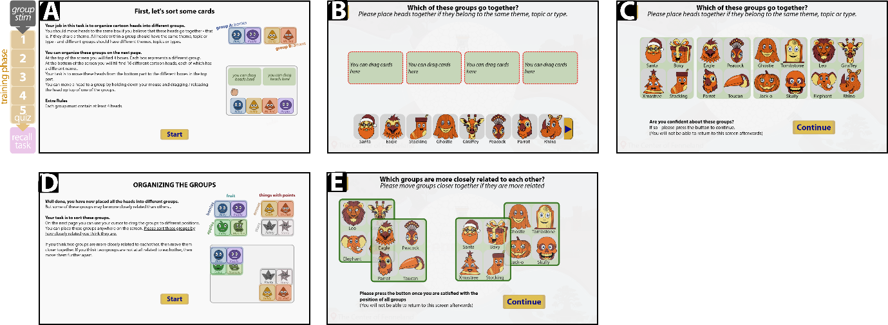
Figure S4: the stimulus check task. Each experiment started with a task conducted to verify whether our hypothesized semantic structure of the different Fennimal heads was consisted participant’s own subjective grouping. This task consisted of two phases. A: at the start of the first phase, participants were instructed to create four groups of different heads, such that all elements of a group shared a “theme, topic or type”. Each group could contain at most four Fennimals. B: after closing the instructions, participants saw the four groups (green boxes) and 16 cards on the bottom of the screen (participants could scroll sideways to reveal more cards). Each card contained the head of a Fennimal and its associated name. All heads were colored in the same three colors. C: after participants placed all Fennimal in the four boxes, they could press a button to continue to the next phase. D: at the start of the second phase, participants were tasked with moving the position of the four groups created during the first phase. They were given the instruction to move groups closer together if they perceived the contents of these groups to be more similar to each-other, and to move them further apart if their contents are less similar. E: at the start of the second phase, all four boxes were positioned on top of each other in the center of the screen. Participants could then drag these boxes to different locations on the screen. After they moved all boxes, a button appeared at the bottom of the screen. Pressing this button completed the stimulus check task.

Training phase
After the stimulus check task, participants continued to the training phase of the experiment. This phase consisted of five blocks and constituted the majority of the experiment. At the start of each block the software reset the map – that is, it removed all Fennimal icons from the map and listing each Fennimal as ‘unvisited’.
The first block was designed to familiarize the participants with the island and the Fennimals (Figure S5). At the start of the block, participants were next given instructions on how to interact with the software (Figure S5A). During this block participants could freely travel the island to explore its layout. At the start of the block participants were shown a set of blacked-out photos, containing the outline of all 16 Fennimals (Figure S5B). These outlines were replaced with polaroid-framed photos when participants completed the interaction with the Fennimal (Figure S5C). This block continued until participants had interacted with all 16 Fennimals on the island.
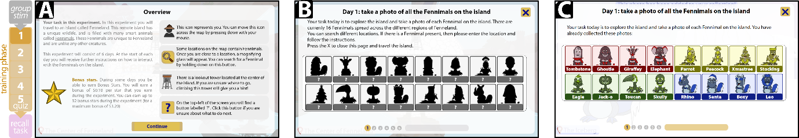
Figure S5: the first block of the training phase. During this block participants could freely explore the island until they interacted with all 16 Fennimals. A: at the start of the block participants were given instructions on how to interact with the software. In addition, they were informed that they could earn a maximum of 32 bonus stars – each of which was transformed to a bonus of $0.10 at the end of the experiment. B: At the start of the block, participants were shown 16 silhouettes of the to-be-found Fennimals. These silhouettes were replaced with colored-in versions whenever a participant completed the interaction this Fennimal. C: At the end of the block participants were shown an overview of all the Fennimals they encountered during this block. The order of these Fennimals reflects the order in which they were found by the participant.
The second block was designed to further enhance the memorability of each Fennimal’s visual features and was organized along 16 trials (Figure S6). At the start of each trial, participants were shown a miniature depiction of a target Fennimal, with corresponding task to travel to this Fennimal (Figure S6B). Participants could then freely enter the map, and entering the location containing the target Fennimal triggered an interaction with the Fennimal after which participants had to enter the name of the Fennimal (Figure S6C). After correctly entering the name of the Fennimal (or failing to do so on three attempts), participants received further instructions containing the miniature of the next Fennimal to be found. This continued until all 16 Fennimals had been interacted with, after which participants continued to the next block. These trials were presented in a pseudo-random order, such that all Fennimals which were located in the same region were presented sequentially. This was done to minimize participant’s travel times across the island and thereby minimize the duration of the experiment.
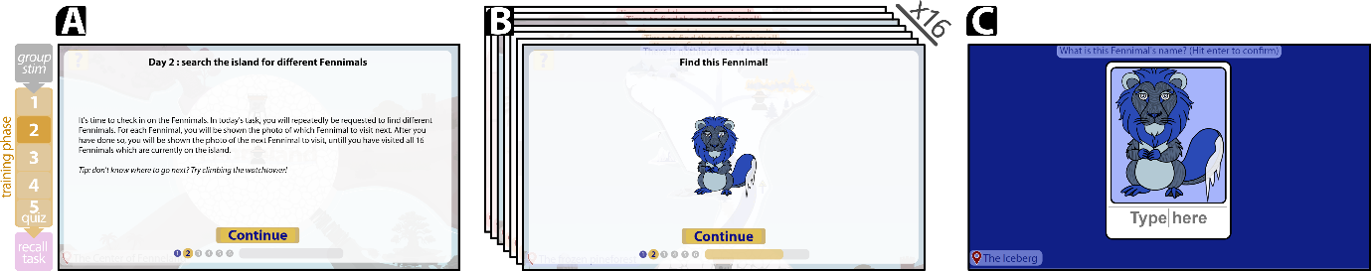
Figure S6: the second block of the training phase. This block was designed to enhance the memorability of each Fennimal’s visual features. A: instructions given to participants at the start of the block. B: this block consisted of 16 trials. At the start of each trial, participants were shown a miniature Fennimal. Participants then had to travel to the location which contained this Fennimal. Entering this location triggered an interaction as outline above. C: during this block, participants had to enter the name of the Fennimal in the polaroid picture frame. Participants were given three attempts. After failing the third, the name was revealed and participants continued to the next trial.
The third block was designed to enhance the memorability of each Fennimal’s native region on the map and consisted of a single task (Figure S7). During this task, participants saw a screen containing four boxes (one for each region included in the region) and a sequence of cards containing the head of a Fennimal (presented one at a time at the top of the screen; Figure S7A). Participants were tasked with dragging these cards to the region in which these Fennimals has previously been encountered. If the card was released on top of an incorrect region, then the card snapped back to its original position at the top of the screen. If the card was released to its correct region, then it snapped to position within this box, then the card was blurred and a new card appeared on the top-center of the screen. Participants could move their cursor over any card to unblur their contents. This task continued until all 16 cards (one for each Fennimal) has been placed in their correct regions. Placing the last card caused all cards to be unblurred (Figure S7C) and participants could then continue to the next block.
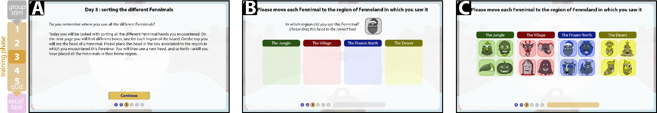
Figure S7: the third block of the training phase. This block was designed to enhance participant’s association between the regions of Fenneland and their constituent Fennimals. A: instructions provided to the participants. B: participants were presented with a screen containing four boxes, one for each region of Fenneland which was visited during the experiment. At the top of the screen participants saw the head of a Fennimal, and had to drag this head to the region in which it was previously encountered. If the head was dragged to a wrong location, it then automatically returned to its starting position as shown on this screenshot. If the head was dragged to the correct location, then the head was positioned within the box and was set to be no longer draggable. The next head then appeared on the starting location. This continued until all 16 heads were placed in their correct box. C: a screenshot showing the final state of this block after all heads were correctly placed.
The fourth block was designed to enhance the memorability of each Fennimal’s name (Figure S8). The setup of this block was similar to that of the third block and consisted of one trial for each Fennimal) The difference between the second and third blocks was the hint provided to participants: instead of being shown a miniature depiction of the Fennimal, participants now only saw the Fennimal’s name (Figure S8B). Participants then had to remember where they previously encountered this Fennimal and then travel to this location. In order to challenge participants into maximizing their focus during this block, all trials were presented in a fully randomized order – that is, without the requirement that subsequent trials took place in the same region. As in the second block, participants had to enter each Fennimals name in the polaroid frame.
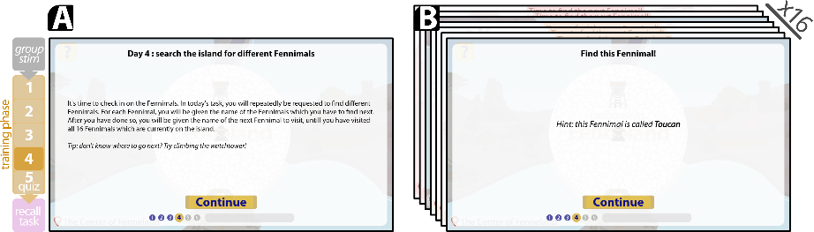
Figure S8: the fourth block of the training phase. This block was designed to enhance the memorability of each Fennimal’s name. A: instructions given to participants at the start of the block. B: this block consisted of 16 trials. At the start of each trial, participants were shown the name of a Fennimal. Participants then had to travel to the location which contained this Fennimal. Entering this location triggered an interaction as outline above.
Finally, the fifth block contained a quiz designed to verify whether participants had successfully memorized the Fennimals, their home regions on the map and their names (Figure S9). This quiz consisted of 16 questions, one for each Fennimal. Each question was presented on a separate page. In order to incentivize their performance, participants earned one bonus star per correctly answered set of quiz answers (for a maximum of 16 stars). Each quiz page contained a gray-scale version of the Fennimal’s head (Figure S9B). Participants were then asked to type down the Fennimal’s name (“What is this Fennimal’s name?”; answers via text input) and to select which in which region this Fennimal was previously encountered (“In which part of the island did you see this Fennimal?”; answers via a drop-down menu listing all regions which were visited during the experiment”). Once participants answered both questions, a button labelled “Check answers” appeared on the screen. Upon pressing this button participants were informed which of the questions were answered correctly or incorrectly (Figure S9C). If a question was answered incorrectly, the correct answer appeared below the question in a red font. Participants could then press a button labelled “Continue” to move to the page.
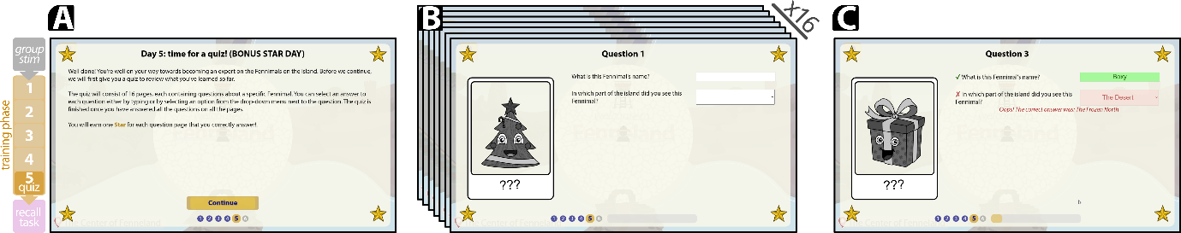
Figure S9: the fifth block of the training phase. This block was designed to verify whether participants had successfully memorized all the training stimuli. A: instructions provided to the participants. In order to incentivize performance, participants were told that they would earn a bonus star for each page of correctly answered questions. B: the quiz consisted of 16 pages, one for each Fennimal. The left-hand side of each page contained a grayscale Fennimal head within a polaroid photo frame. The right-hand side of the page next contained two questions. First, participants were asked to type the Fennimal’s name (free text input). Participants were then asked to select the region of Fenneland in which this Fennimal was encountered (drop-down menu with one option for each of the four regions visited during the experiment). C: after submitting their answers, participants were given feedback on whether they made any mistakes. Any questions which were incorrectly answered were printed in red, and the correct answer was presented below the question.

Memory recall phase
Participants next continued to the recall phase of the experiment, which collected the main dependent variables (Figure S10). This phase consisted of a single task, in which participants were asked to “Please write down all the names of the different Fennimals which you can remember”. The remainder of this page contained a box containing all submitted names, and an input field to add more answers (Figure S10A). Once entered, the previously recalled names appeared as blurred items in the larger box (Figure S10B). This blurring was included to prevent previously written names to form confounding cues for the retrieval of additional names. Participants could remove any submitted names by pressing an (unblurred) red “X” next to the blurred name. After participants listed all recalled names, they could complete the task by pressing a button labelled “Done”. In order to incentive their performance, participants were informed that they would earn a bonus star for each successfully remembered name.
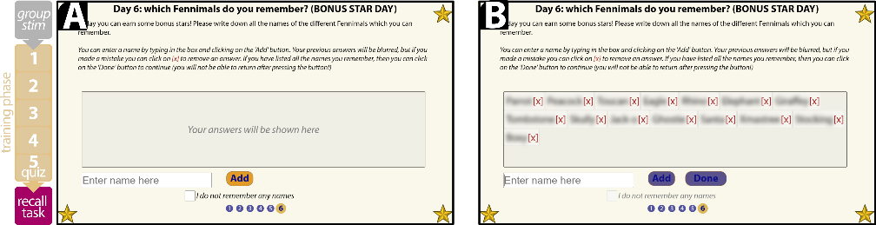
Figure S10: the recall task. This task collected the main dependent variable of the experiment: the names (and the order of names) recalled by the participant. A: during this task participants were asked to write down the names of all the Fennimals they recalled. As a performance incentive, they earned one star for each correctly recalled Fennimal. Participants could enter a name in the textbox containing the default text “Enter name here” and then press the button labelled “Add” to add this Fennimal. The entered text was then displayed in the box above this text input field. B: example depicting the task with a number of submitted names. In order to prevent confounds by unintentionally cuing the participants with previously entered names we blurred the text of all names once they were entered. Participants could remove erroneously entered names by clicking the red “[x]” next to the blurred name. Participants could click a button labeled “Done” once they had finished listing all the names of the Fennimals they remembered.
After participants finished the task, the software automatically attempted to match each submitted name to the Fennimal’s actual names. In order to do so while allowing for minor typos the software first calculated the capital-insensitive Levensthein distance (Levenshtein, 1966) between the participant’s input and each actual name. This distance represents the number of letters which need to be removed, added or substituted to transform the participant’s input and the actual name. If this distance did not exceed 2, then the participant’s input was matched to the corresponding Fennimal’s name.
During this task, the software recorded the names entered by participants, any match of these names to the Fennimal’s names, the order in which these names were entered and the time at which the name was entered.

Questionnaire and payment
Upon completing the memory recall phase participant were given a brief questionnaire, asking participants about their age (“What is your age?”; answered via a numeric input), their self-identified gender (“What gender do you identify as?”; answered with a drop-down menu containing the options “man”, “woman”, “other”, “don’t want to say”) and whether they had any form of color-blindness (“do you have any form of color-blindness?”; answered via a drop-down menu containing the options “yes”, “no” and “I don’t know”). After answering all questions, participants continued to the final pages of the experiment where they learned the amount of bonus stars earned during the experiment.

Between-subjects randomization
In order to prevent any confounding effects, the experiment software included a large degree of between-subject randomization (Figure S11). At the start of each experiment, the software selected four out of the available eight regions. All 16 Fennimals were then placed in the locations of these regions. The software first created four groups of heads. Each group consisted of two pairs of heads, selected such that both pairs were selected from semantically different clusters. These heads were selected without replacement, resulting in the creation of four groups: ‘Safari-Halloween’, ‘Safari-Christmas’, ‘bird-Halloween’ and ‘bird-Christmas’. These groups were then randomly assigned to the four selected regions, and each group’s heads were randomly assigned to different locations within this region.
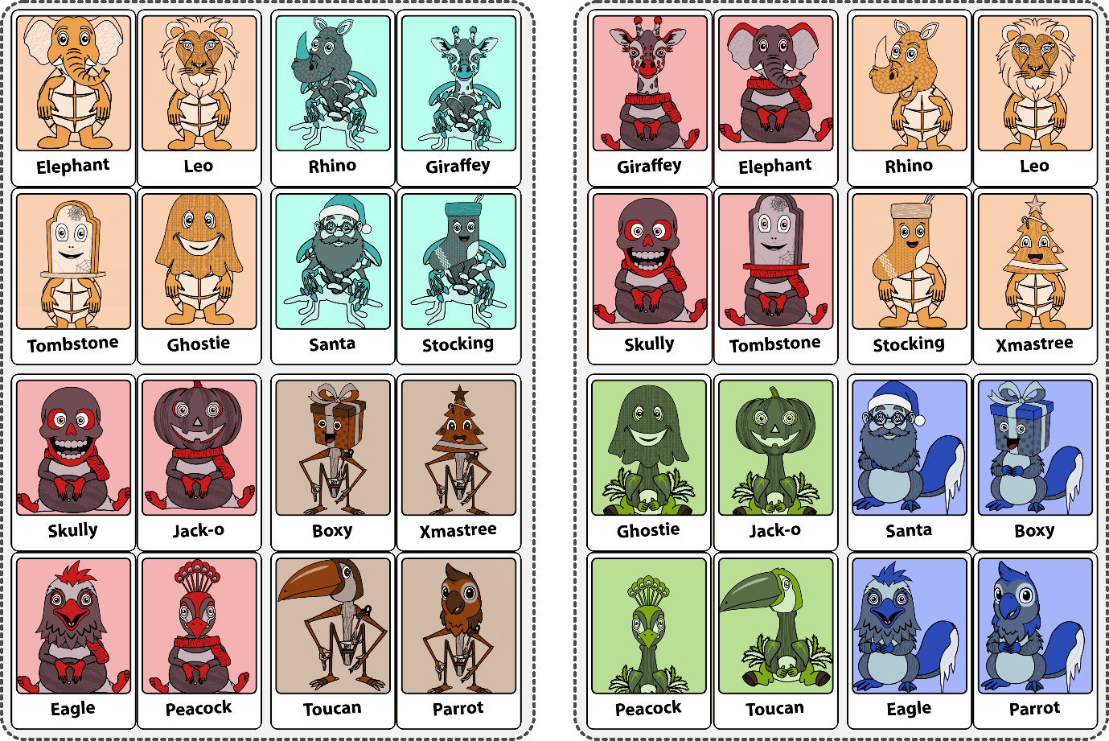
Figure S11: example sets of Fennimals for both treatments. The experiment software allowed for a large degree of between-subjects randomization. At the start of each experiment, four regions were selected in a random order to place the Fennimals. Fennimals were then placed on the island such that each region had to contain two pairs of Fennimals, belonging to two different semantic clusters. Note that each head was only encountered once during the experiment.

Supplementary Information: Detailed procedure for the permutation tests
At the start of the statistical analysis procedure, we first transformed each participant’s ordered list of recalled names into a series of steps along a mnemonic network. Each of these steps had a starting point (the previously retrieved name), an end-point (the currently retrieved name) and an associated duration (the time between both entries). Thus, if a participant had recalled k names, then this yielded k-1 steps between names. For each step we next determined whether the step occurred within the same region (i.e., did both names belong to Fennimals which were encountered in the same region of Fenneland) and whether it occurred within the same semantic group or semantic cluster (i.e. did the names and heads of both Fennimals belong to the same semantic group or cluster). We next evaluated our hypotheses using a series of permutation tests. Two types of tests were used: one to test the frequency of steps and one to test differences in step time durations.
One set of permutation tests was conducted to analyze the observed frequency of the different types of steps; that is, the frequency by which two sequentially recalled names belonged to Fennimals which were either observed in the same region of Fenneland, and/or whose heads belonged to the same semantic group or cluster. These tests were used to evaluate hypotheses 1A, 2A, 3A and 3B. Here we evaluated whether some steps occurred more frequently than expected due to random chance alone. We first recorded the frequency for the observed overlap-of-interest in our data. This was then compared to a simulated distribution consisting of 10,000 samples. In order to minimize statistical assumptions, in each sample we simulated an equal number of participants as in the observed data and such that each participant recalled the same number of names. However, in contrast to the observed data, we simulated these participants as if they followed a random walk retrieval process; that is, as if they retrieved the names of the Fennimals in random order and with equal probability. For each sample we then computed the simulated frequency of the simulated overlap-of-interest and compared the percentage of samples which had an equal or greater frequency of than the observed (actual) overlap-of-interest; thereby yielding a one-sided permuted p-value.
A variation of this procedure was used for a second set of permutation tests, which were conducted to evaluate the differences in duration between different types of recall steps. As before, we first calculated the observed difference in either mean retrieval time between two groups of step-types (that is, into groups of sequentially retrieved names in which the two Fennimals had a specific overlap in either episodic features or semantic features). This observed difference was then compared to a simulated distribution consisting of 10,000 samples. In each of these samples we assumed the null-hypothesis of no difference between the two groups by randomly shuffling their grouping label. For each sample we then computing the observed difference between the two groups of interest, and then calculated which fraction of these simulated draws equaled or exceeded our observed difference; thereby yielding a one-sided permuted p-value.

Supplementary Information: Pilot experiment to replicate semantic retrieval
The Fennimals paradigm was previously developed to explore episodic, but not semantic, retrieval. We therefore conducted a modified version of the experiment to evaluate whether our paradigm replicates previous findings on the semantic structure of memory retrieval (Figure S12). In this modified design, we distributed the Fennimals on the island such that all Fennimals in the same region belong to the same semantic group (Figure S12A). We next conducted the experiment as outlined above with a total of 37 online participants. Of these participants, 9 were excluded from further analysis as they failed to recreate the predicted grouping structure in the stimulus check phase. As the software did not track participant’s engagement or idle time, we instead excluded one participant for exceeding a total experiment duration of 3300 seconds (approximately twice the median duration of earlier pre-pilot experiments). Of the remaining 28 participants, 22 identified as men and 6 as women, and they had a mean age of 37.5 years. The experiment had a median time to completion of 32.1 minutes and participants recalled a mean number of 14.8 out of 16 Fennimal names.
The order in which these participants recalled the names of the Fennimals replicates previous findings on the semantic structure in memory retrieval. Participants sequentially retrieved names of two Fennimals from the same semantic cluster in 75% of cases. We conducted a permutation test to evaluate this frequency against 10,000 simulated permutations in which participants followed random walk. In these simulations, participants retrieved the names of two Fennimals in the same semantic cluster in 20% of cases, and our observed percentage was significantly higher than would be expected based on chance (Figure S12B, one-sided permuted p <.001). When participants sequentially retrieved the names of Fennimals belonging to different semantic groups, then they recalled the names of two Fennimals in the same semantic cluster (e.g., switching from ‘safari animals’ to ‘birds’) in 51% of all observed switches, which was significantly more than expected by chance (Figure S12C, simulated chance frequency = 33%, permuted p < .001).
The pattern by which participants switched between different retrieving names from semantic groups was consistent with an autocorrelated walk in semantic space (Figure S12D; (Abbott, J. T. et al., 2012; Abbott et al., 2015)): when retrieving the name of a Fennimal, the subsequent name most frequently belonged to the same semantic group. If the next name belonged to a different group, then participants were most likely to subsequently retrieve a name from the other group in the same cluster.
Finally, these results replicate the time required to sequentially retrieve names as predicted by optimal foraging models (Figure S12E, (Hills et al., 2008, 2012, 2015)). During the retrieval of the Fennimal’s names, the time between sequentially retrieved names increased as participants recalled more names from the same group. Eventually, no more new names in the same group are retrieved, and participants next switched to retrieving names belonging to a different semantic group. This switch requires substantially more time than the average duration between two names. After the switch, names in the new group are retrieved substantially faster – albeit increasingly slower as more names are retrieved from the same semantic group, thus repeating the pattern.

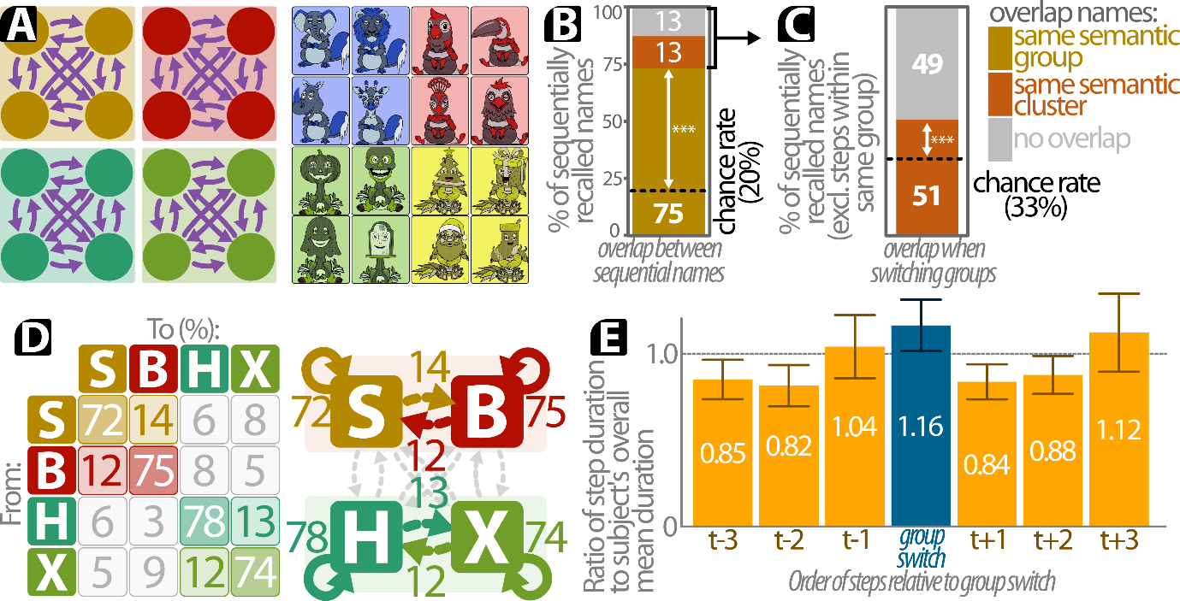
Figure S12: the modified Fennimals paradigm replicates previous findings on the semantic structure of memory retrieval. A: in this pilot experiment all Fennimals were placed on the island such that each region contained four heads belonging to the same semantic group. The rest of the procedure, including randomization, was conducted as planned for the main experiment. The right panel provides an example set of stimuli. B: we transformed each participant’s order of sequentially recalled names into a set of steps, and counted the overlap between both Fennimals in each step. The results from a permutation test indicate that participants significantly were more likely than chance to sequentially name Fennimals belonging to the same semantic group. C: When participants sequentially recalled the names of Fennimals in different semantic groups, they were more likely than chance to name two Fennimals belonging to different groups in the same semantic cluster. D: the order in which participants recalled names belonging to different semantic groups was consistent with an autocorrelated walk in semantic space. When retrieving the name of a Fennimal, the subsequent name was most likely to belong to the same group or to the other group in the same cluster. E: in line with models of optimal foraging, the repeated recall of names in the same group required increasingly more time. Switching to a different semantic group resulted in an additional delay, but was subsequently followed by a decreased duration in retrieval times. Note: *** p < .001

Supplementary Information: Detailed description of the power simulations
We conducted a series of power simulations to determine our minimum sample size. These simulations consisted of two types. First, we simulated our ability to detect the predicted increased propensity of participants to sequentially retrieve two names with shared characteristics (hypotheses 1 & 2). We then conducted a second set of power simulations to evaluate the minimal sample size to detect the predicted differences in retrieval time durations for different types of sequentially retrieved name (hypothesis 3). Note that these simulations reflect a simplified sampling process, and should be read as a broad indication of the power for our statistical analysis.

Simulation for the relative occurrences of overlapping features between sequentially recalled names (hypotheses 1 & 2).
In each simulation we first determined a simulated effect size (‘x’) and a simulated sample size. At the start of each simulation, we determined the number of names recalled by each participant. To minimize the need for (potentially arbitrary) assumptions, we sampled the number of recalled names for each simulated participant from the actual distribution of the number of names recalled by participants in the relevant pilot experiment. We then simulated the sequences in which all simulated participants recalled the different names of the Fennimals. Each simulated participant retrieved the first name at random. For each following names we determined the relative probabilities for recalling each remaining (that is, not yet retrieved) Fennimal based on the simulated propensity value. The relative rate that the participant selected a name without any overlap to the previous name was set to a relative probability of 1, while the propensity of sequentially retrieving the name of a Fennimal with overlapping features is provided in Table S2. A subsequent name was then retrieved based on these relative probabilities, and then the next set of sequential probabilities was based on the features of the retrieved Fennimal. This continued until the simulated participant recalled its allotted number of names.
Relative probability to retrieve a subsequent name with the following overlapping features:
 | No overlap | The same region | The same semantic group | Different group in the same cluster | The same region and group
Relative probability | 1 | 1 + x | 1 + x | 1 + 0.5x | 1 + 2x
Table S2: relative propensities to select a sequential Fennimal, based on its overlap in features to the previously recalled name. X represents the simulated effect size.
After simulating the sequence of recalled names for all participants, we conducted the same statistical tests as were used to analyze the data outlined in the main body of this text (and as further described in the Supplementary Information). For computational reasons, we limited the number of simulated permutations to 500 per test. We then recorded whether the resulting p-value. For each combination of simulated propensity and sample size, we repeated this procedure 500 times to minimize statistical noise. We then calculated our simulated power as the percentage of simulations in which the resulting p-value was smaller than .05.
Figure S13 provides the results of these power simulations. We simulated four levels of sample size: the dashed (red) line represents the observed power for the sample size we obtained in the pilot experiment (30), versus the observed power for 100, 125 and 150 participants. The results suggest that we obtain sufficient power (0.95, represented by the dotted horizontal line) for all hypothesis by collecting around 125 participants, assuming a relatively small effect size of approximately 1. As a comparison, the observed value of x falls between 2.5 (for two names in the same region) and 3.2 (for two names in the same semantic group). As our simulations yield a broad indication of the power, we opted to recruit a sample of 150 participants to include a safety margin for reasons of prudence.
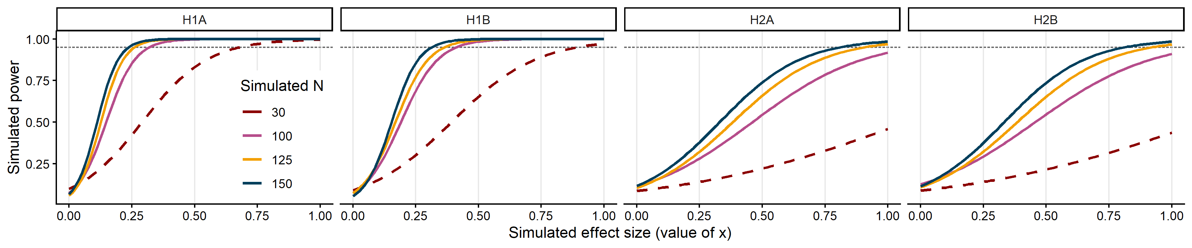
Figure S13: power simulations for hypotheses 1 and 2. The four colored line indicate different simulated sample sizes, whilst the x-axis denotes the simulated effect size. The red dashed line represents the sample size of the pilot experiment.

Retrieval time simulations (hypothesis 3).
In contrast to the hypotheses simulated above, hypotheses 3_{A} and 3_{B} predict a difference in retrieval times between sequentially recalled names. We conducted an additional set of power simulations to evaluate our ability to correctly identify various effect sizes for these predictions. We conducted different power simulations for the same four different same sizes as above, and with different simulated effect sizes y. Each simulated started by determining the number of names which were recalled by the participants. To minimize the need to rely on potentially arbitrary assumptions, each simulated participant’s number of recalled steps was sampled at random from the distribution of the number of recalled names in our pilot experiment. We next simulated a set of sequentially recalled names for each participant. As with the number of names per participant, we sampled the type of recalled names based on the distribution of step-types as observed in the pilot experiment. This resulted in a list of recalled step-types for each simulated experiment. We then assigned a random retrieval time to each step, again sampled from the distribution of retrieval times as observed during the pilot experiment. Finally, we subtracted 0.5y milliseconds from any step steps which were hypothesized to be faster, and added 0.5y milliseconds to any step types which were hypothesized to be slower. We then tested our analyses on this simulated data as outlined in analysis plan above. For each simulation we then stored the p-value for these tests. To reduce the impact of statistical artifacts, we simulated 1000 different datasets, with 1000 simulated tests per dataset (for each combination of a simulated sample size and effect size).
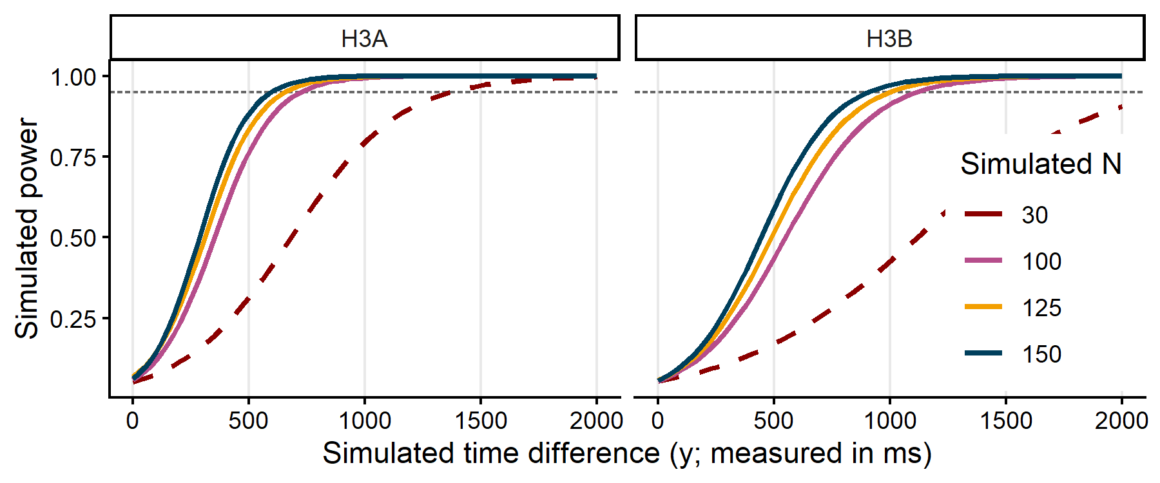
Figure S14: power simulations for hypotheses 3. The four colored line indicate different simulated sample sizes, whilst the x-axis denotes the simulated effect size. The red dashed line represents the sample size of the pilot experiment.
Figure S14 provides the results for these power simulations. Starting from a sample size of 100, we are sufficiently powered (>95% power) to detect a simulated median time difference of approximately 750ms for hypothesis 3A, and 1100ms for hypothesis 2B. For a sample size of 150 participants we are sufficiently powered to detect a median difference of approximately 600ms and 800ms for both hypotheses, respectively.

